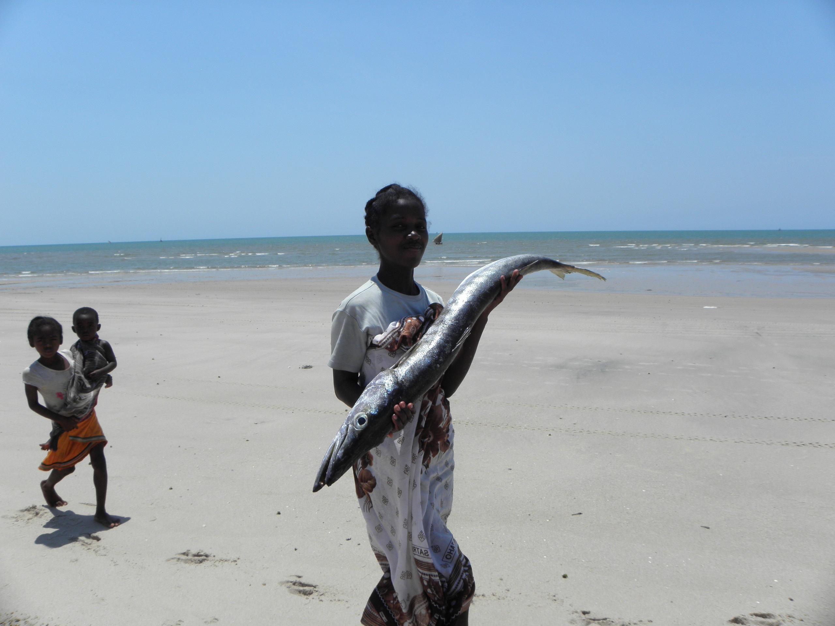
A technical case study for the WAVES Global Partnership in Madagascar

March 2013
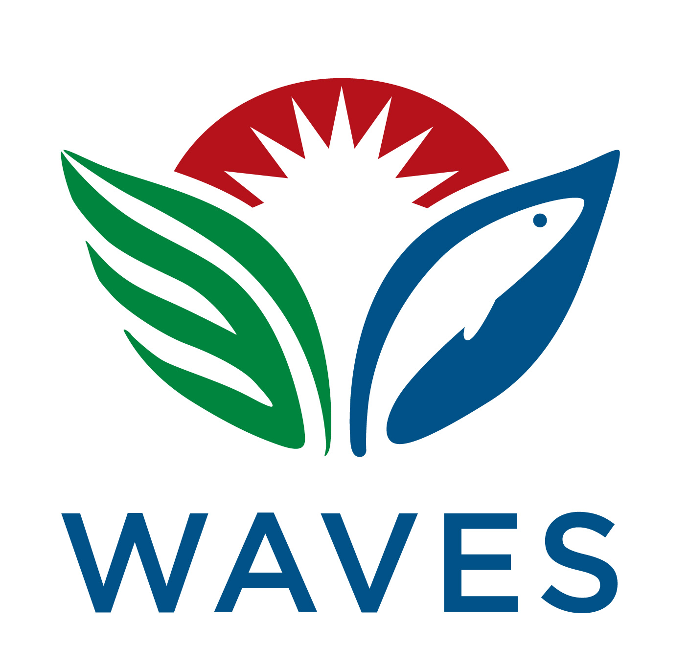
08
Automne
Frederic Le Manach, Charles Andrianaivojaona, Kirsten Oleson, Alison Clausen & Glenn-Marie Lange
Natural capital accounting and management of the Malagasy fisheries sector

Table of Contents
- I. Introduction and Background 1
- I.1 Introduction 1
- I.2 Background 1
- I.3 Objectives of the Study and Structure of the Report 3
- II. Description of Madagascar’s Fisheries Sector 5
- II.1 Fisheries Sector Structure and Value 5
- II.2 Fisheries Sub-Sector Profiles 13
- III. Overview of Fisheries Sector Governance 22
- III.1 Institutional Structure 22
- III.1.1 Ministry of Fisheries and Aquatic Resources 22
- III.1.2 Regional Directorates 25
- III.1.3 Other Governmental Institutions 25
- III.1.4 Private Sector and Civil Society 26
- III.1.5 Technical and Financial Partners 26
- III.2 Policy Framework 26
- III.3 Legislative Framework for the Fisheries Sector 27
- III.4 Legislative Framework for Related Activities 29
- IV. Conclusions and Recommendations 30
- IV.1 Key Conclusions from Technical Case Study 30
- IV.2 Opportunities for WAVES Phase 2 Activities 31
- V. References 33

List of Tables
- Table 2.1: Target species exploited by fisheries sector 5
- Table 2.2: Official and Reconstructed Statistics for Domestic Catch Volumes 7
- Table 2.3: Official data on export volumes (2010 – 2011) 9
- Table 2.4: Official data on export value (2010 – 2011) 10
- Table 2.5: Summary of data and data gaps for total economic value of fisheries sub-sectors (2010) 11
- Table 2.6: Official statistics on fishers by district (1988 and 2011) 12
- Table 2.7: Tuna agreements effective in Madagascar (2011) 17

List of Figures
- Figure 1.1: Madagascar’s Marine and Coastal Zone 2
- Figure 2.1: Map of fishing zones by sector and target species 6
- Figure 2.2: Organization of the different fisheries sectors in Madagascar 7
- Figure 2.3: Evolution in domestic catch volumes (1950 – 2008) 8
- Figure 2.4: Non-fiscal revenues in fisheries sector (2000 – 2010) 11
- Figure 2.5: Geographic distribution of fishers based on official estimates (2011) 13
- Figure 2.6: Evolution of shrimp landings since 1950 and comparison to MSY (2009) 15
- Figure 2.7: Evolution of the fishing effort in the commercial shrimp fisheries 16
- Figure 3.1: Organizational structure of MPRH 22

Annexes
- Annex 1: Number of fishers by district, in 1988 (census) and 2011 (estimates) 38
- Annex 2: Official domestic fisheries statistics and reconstructed statistics 40
- Annex 3: Average market prices for fish catch 42
- Annex 4: Locally Managed Marine Areas (LMMAs) and Marine Protected Areas (MPAs) in Madagascar 43

Acronyms & Abbreviations
AfDB | African Development Bank
AMPA | Malagasy Fisheries and Aquaculture Agency
ASH | Marine Sanitary Authority
CCGP | Consultative group for fisheries management
CCPPA | Regional consultative council for fisheries management
CPUE | Catch per unit of effort
CSP | Fisheries Surveillance Center
DGPRH | Direction-General of Fisheries and Aquatic Resources
DRPRH | Regional Direction of Fisheries and Aquatic Resources
EEZ | Exclusive economic zone
EU | European Union
FAO | Food and Agriculture Organization of the United Nations
GAPCM | Malagasy Shrimp Aquaculture and Fisheries Group
GDP | Gross domestic product
GELOSE | Community based natural resource management contract
GRT | Gross registered tonnage
ICZM | Integrated Coastal Zone Management
LMMA | Locally managed marine area
MPA | Marine protected area
MPRH | Ministry of Fisheries and Aquatic Resources
MSC | Marine Stewardship Council
MSY | Maximum sustainable yield
NGO | Non-governmental organization
OEFC | Shrimp Economic Observatory
SEEA | System of Environmental and Economic Accounting
TEV | Total economic value
UNCLOS | United Nations Convention on the Law of the Sea
USD | United States dollar
USTA | Statistics Unit of the Antsiranana Tuna Processing Plant
WAVES | Wealth Accounting and Valuation of Ecosystem Services

EXECUTIVE SUMMARY

1. Madagascar’s fisheries sector – important for local livelihoods & national growth
With a marine zone of over 1 million square kilometers - an area nearly double the national land surface - Madagascar is endowed with substantial marine and coastal resources. Hundreds of thousands of hectares of mangroves on the west coast provide timber, food resources, carbon sinks and coastal protection; coral reefs in the west, northwest and northeast and inshore coastal areas host a high diversity of finfish, shrimp, sea cucumber, octopus and lobster; and offshore waters harbor pelagic fish such as tuna and shark species with high commercial value.
Fisheries activities span a range of scales from subsistence to commercial, and both domestic and foreign operators are active in the industry. Domestic catch made up predominantly of finfish, shrimp, and various invertebrates accounts for the bulk of total catch – approximately 135,000 tons per year. Foreign catch is made up largely of tuna, billfish and shark, however reliable data on catch volumes are lacking.
Official estimates state that in excess of 100,000 people are employed in the fisheries sector, but this figure underestimates the real importance to local livelihoods as significant numbers of households that practice subsistence or seasonal fishing are not counted in official statistics. Many of the country’s food insecurity hotspots are found in coastal areas, highlighting the role that fisheries and coastal resources play for vulnerable communities.
The fisheries sector is also important for national economic development. Despite recent declines in catch volumes in certain sub-sectors, official statistics state that fisheries generated USD 146 million in export earnings in 2011 and contributed in the order of 1.6% of GDP; a figure that is most certainly an underestimate of the true contribution of the sector. The total economic value of the fisheries sector is unknown both because of gaps in official statistics, and the illegal or informal nature of much activity in the sector. Available information indicates that finfish is the most important market-based economic subsector, followed by shrimp (despite recent significant declines in catch), and tuna. The economic value of sharks, sea cucumbers, octopus, and lobster fisheries are unknown.
2. A web of institutions, policies and laws governing the sector
The Ministry of Fisheries and Aquatic Resources, which is comprised of over 40 separate directorates, services and agencies, is responsible for the fisheries sector, while other Government agencies are responsible for related activities (e.g., the Ministry of Environment and Forests administers environmental regulation and marine protected area planning, and the Prime Minister’s office oversees Integrated Coastal Zone Management). All these agencies suffer from a lack of human, technical and financial resources and suffer the effects of regular changes in personnel and Ministerial direction. At the regional level, the situation is even more difficult. Regional fisheries directorates are charged with a wide range of surveillance, education and regulation activities but are often staffed by only one or two personnel with very few resources.
The policy and legal framework governing the sector is incoherent and ambiguous. There is no current official document that states the Government’s fisheries sector policy. A draft sector policy and law have been prepared and subject to discussion within Government agencies, but not yet adopted due to a lack of consensus. The prevailing legal framework is made up of a large number of instruments that, for the most part, date back to the early 1990s and which are by turns contradictory and conflicting.
A national strategy for ICZM was adopted in 2010 and a national and several regional committees were established. However to date there has been little realization of concrete ICZM activities. The development of coastal and marine protected areas is being driven predominantly by NGOs and is subject to a nascent legal framework. Community based natural resource management contracts in the coastal zone are in much the same position having been trialed in numerous locations, but still lack a strong and coherent policy and legal basis.
3. Data gaps and governance challenges undermining management of the fisheries sector
Despite the diversity and richness of its marine and coastal resources, Madagascar remains the fifth poorest maritime country in the world. To date, Madagascar has failed to sustainably manage its fisheries resources in a manner that would allow protection of this renewable resource and optimization of the amount and use of the revenues generated.
The country’s inability to manage its fisheries resources in a sustainable manner is exacerbated by a lack of robust data on stocks, catch volumes and economic values of resources. There are no stock assessments available for Madagascar’s fisheries apart from initial estimates for shrimp. Official data on catch volumes underestimate real data by up to 30% as they fail to account for several important sub-sectors including shark, by-catch and finfish. Economic data are limited and widely dispersed throughout a large number of agencies, many of which are unwilling to share data deemed confidential.
The result is that Madagascar is not only depleting its fisheries stocks without understanding maximum sustainable yields - as has recently been evidenced in the shrimp industry where the causes of massive declines are still being debated, but it is also incurring economic losses either through direct losses or failure to optimize revenue generation.
Notable economic losses to Madagascar arise from discarded by-catch, which is estimated in the order of USD 2.5 million per year from the shrimp industry alone – an amount equivalent to Government income from the tuna fisheries; and illegal or uncontrolled catches by foreign vessels, which are estimated to be in the order of 50,000 tons per year. This latter situation is exacerbated by license agreements with a number of foreign operators that are based only on the number of vessels and not on catch volumes, and a significant lack of resources to monitor and control catches.
4. How could WAVES contribute to the better management of Madagascar’s fisheries sector?
The WAVES Partnership in Madagascar will support the development of fisheries satellite accounts in line with the recently adopted UN System of Environmental and Economic Accounting (SEEA). WAVES will support a review of available data to compile a first set of satellite accounts and work with Government and technical partners to generate additional information to progressively update and improve the accounts. The information provided by these accounts will not only be useful for the development of sectoral policy that is underpinned by robust data on the value of natural capital in the form of renewable fisheries resources, but will also allow a true understanding of the contribution of this component of natural capital to national economic development and human well-being.
WAVES will also work at the regional level by piloting approaches for ecosystem services accounting in southwest Madagascar that can be used to improve ICZM planning and practices. Such approaches will consider the values of fisheries, habitat and coastal protection values of coral reefs and mangroves, tourism, and the implications of climate change in an ICZM context.

Introduction and Background

Introduction
Ecosystems are deteriorating worldwide, and with them, the capacity to support human wellbeing, a problem that is exacerbated by climate change. Part of the solution to this problem lies in policy making that takes into account the full value of natural capital and ecosystem services. Ecosystem and natural capital valuation activities are increasingly focused on ‘greening’ national income accounts. National income accounts are crucial because they constitute the primary source of information about the economy and are widely used by a range of stakeholders for assessment of economic performance and policy analysis.
The overall objective of the Wealth Accounting and Valuation of Ecosystem Services (WAVES) Global Partnership is to promote sustainable development worldwide through the implementation of wealth accounting that focuses on the value of natural capital. The World Bank will lead this initiative in a partnership with the United Nations, interested developing and developed countries, NGOs and other organizations. The WAVES Partnership has four components: (i) implementation of natural capital accounting in selected pilot countries; (ii) incorporation of natural capital accounts in policy analysis and development planning; (iii) development of a methodology for ecosystem accounting for the UN’s revised Handbook for the System of Environmental and Economic Accounting (SEEA); and (iv) promotion of the adoption of natural capital accounting beyond the pilot countries.
Madagascar has been selected as a partner country to participate in the WAVES Global Partnership. Partnership activities in Madagascar are being carried out in two phases: (i) Phase 1 (February 2011 to June 2012): Preparation phase during which time two technical case studies and country specific Feasibility and Planning studies were prepared, and presentation of WAVES activities were made to the Rio+20 United Nations Conference on Sustainable Development; and (ii) Phase 2 (2012 – 2015): Implementation phase during which technical project activities will be implemented.
Given the importance of fisheries both to national economic development and subsistence livelihoods, it was decided to undertake a technical case study to investigate the means by which WAVES could contribute to improved sustainable management of the fisheries sector in Madagascar. This report presents the results of the case study undertaken in the fisheries sector.

Background
With a land area of approximately 587,000 km² and an Exclusive Economic Zone (EEZ) of over 1 million square kilometers, Madagascar is the fourth largest island in the world and has a coastline of more than kilometers. It is located in the western Indian Ocean, and separated from the East African mainland by the 400-kilometer wide Mozambique Channel (Figure 1). With GDP per capita estimated at USD 453 in 2010 (INSTAT, 2011), Madagascar is categorized amongst the poorest countries in the world and is the fifth poorest maritime country (World Bank, 2010). Since 1980, GDP/capita has decreased in real terms due to rapid population growth and modest economic performance.

Madagascar exhibits a broad range of geological, oceanic and climatic environments. The eastern part of the country is mountainous, covered by a large rainforest, and possesses a relatively narrow continental shelf facing the prevailing trade winds and oncoming east equatorial current. The western half of the country is characterized by expansive arid plains, and the coast is fringed by a wide continental shelf (Figure 2) (Cooke et al, 2003). On a north-south axis, variations also exist: the southern region is subject to more arid conditions which restrict its agricultural potential (Jury, 2003; WFP, 2006), while the northern region is more humid and therefore offers more agricultural opportunities.

Figure 1.1: Madagascar’s Marine and Coastal Zone
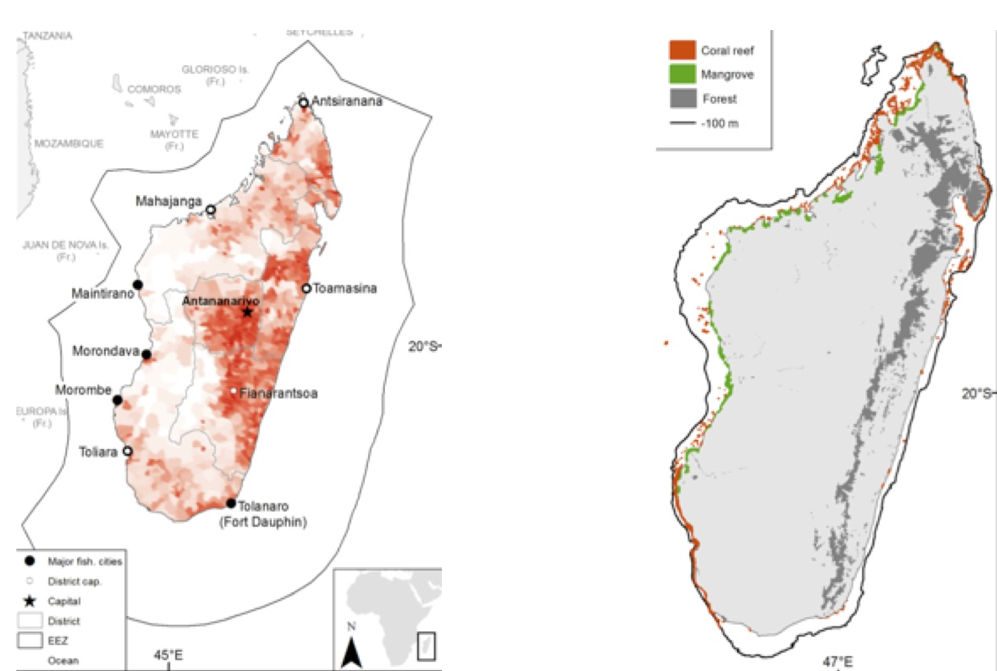

(a) Location of Madagascar with EEZ limit in grey (b) Dark grey line shows the extent of the coastal shelf; forest cover is shown in dark grey shading
Source: World Bank Study Team

Geographical differences are also observed in the country’s marine ecosystems. Malagasy mangroves cover approximately 300,000 - 400,000 hectares (Wilkie & Fortuna, 2003) (2% of the world total (Giri et al, 2011)) and are almost exclusively present on the west coast (Giri & Muhlhausen, 2008), whereas coral reefs are found along the west as well as the northeast coasts (Figure 2). Madagascar’s coral reef network is one of the largest reef systems in the Indian Ocean, covering in the order of 2,000 to 4,000 km² (Burke et al, 2011; Spalding et al, 2001). These ecosystem variations have resulted in spatial divergence in the distribution of the island’s human population: While the eastern part of the island has the highest human population density, the west coast is home to the majority of fishers who take advantage of the extensive reefs, mangroves and continental shelf. Fishing pressure is therefore higher along the west coast of the island, particularly the southwest, and is concentrated in waters close to the coast (Allnutt et al, 2012; Bellemans, 1989; Guidicelli, 1984; Laroche et al, 1997; MPRH, 2011).

Threats to coastal and marine sources are both direct and indirect. The country’s extreme levels of poverty – poverty levels are in excess of 80% in rural areas - and the fact that many food insecure areas are located along the coast, ensure that marine resources play a crucial role in the combat against food insecurity. However, Madagascar’s human population is quickly growing, and the fisher population may be increasing even faster than the total population due to a Malthusian effect caused by land use change, as farmers losing agricultural opportunities (e.g., erosion, drought) are attracted by fisheries resources (Pauly, 1990; Pauly 1994). The result is that certain resources are subject to overexploitation. Habitat destruction, particularly in mangrove areas and coral reefs, is another important threat to coastal and marine resources. In many areas, mangrove wood is used for fuelwood or to produce charcoal. Mangroves are, however, of prime importance for marine life, as they provide nursery habitat for many fish and primary habitat for many other species (e.g., shrimp, crab, eel). Coral reefs and their associated fisheries are also threatened. Gleaning of coral reefs has caused extensive physical damage in the southwest. Reefs are destroyed in the north for use as porous stone in septic tanks, and upstream clearing and runoff of polluted waters has led to sedimentation in coastal areas causing reef disease and degradation. Added to these direct threats are the adverse effects of climate change that is likely to cause coral bleaching, mangrove dieback through sea level rise, and possibly increased resource exploitation in marginal agricultural areas as farmers and herders increasingly turn to fishing to replace or supplement livelihoods.

Despite the significant national and international attention paid to Madagascar’s terrestrial biodiversity, historically, researchers and policy makers have paid less attention to the country’s coastal and marine ecosystems. There is little detailed information on the economic value or the biological and physical characteristics of services that these ecosystems provide to society.

The lack of scientific and economic data on marine ecosystems has implications for their management. The fisheries sector has received relatively little policy attention from the Malagasy government and international agencies, with the exception of a number of NGOs working in conservation and international organizations focused on aquaculture. Based on official statistics (which under-report the importance of the sector), the fisheries and aquaculture sector is one of the most important economic sectors in the nation. If managed sustainably, the production potential of the renewable resources in coastal and marine environments is substantial, but many resources are already overharvested, and some have suffered significant and rapid declines in recent years.

Objectives of the Study and Structure of the Report
The fisheries sector was selected as the subject of a case study for Phase 1 of WAVES in Madagascar because of its importance to national economic development and its potential to contribute to poverty reduction and increased food security. The overall objective of the case study is to identify the data gaps and governance issues that are compromising effective management of the Malagasy fisheries sector, and to identify ways in which activities in Phase 2 of the WAVES Global Partnership could contribute to redressing current shortcomings. Specific objectives of the study are: (i) characterization of economic activity in the fisheries sector; (ii) identification of data availability and data gaps in relation to economic activity in the sector; and (iii) analysis of strengths and weaknesses of current policy and institutional framework; and (iv) identification of potential policy entry points where WAVES activities could contribute to strengthening the policy framework.

This report synthesizes the findings of two research reports commissioned by the WAVES Partnership on the economics of the fisheries sector and the institutional and policy frameworks (Andrianaivojaona, 2012; Le Manach, 2012). The report is structured as follows: the overall fisheries sector is described, including the size, location, and value of key component sectors; the administrative roles and mandates are described followed by the prevailing policy and legal frameworks; and finally a series of conclusions on the sector, and recommendations for future WAVES activities are provided.

Description of Madagascar’s Fisheries Sector

Fisheries Sector Structure and Value

Species Targeted and Spatial Distribution of Fishing Activity
Malagasy fisheries target numerous species (refer Table 2.1). Further information on the scale of fishing activities for each of the sub-sectors is provided below.
Table 2.1: Target species exploited by fisheries sector
Fishery Sub-Sector | Scale of Fishing Activities | Target species
Shrimp | Small to large | Fenneropenaeus indicus  Metapenaeus monoceros  Penaeus semisulcatus  Other penaeids
Tuna and other large pelagics | Large | Thunnus alalunga  T. albacares  T. obesus  Katsuwonus pelamis  Billfishes (e.g., Istiophoridae, Xiphiidae)  Sharks (all pelagic species)
Shark | Small to large | All species
Shark | Large | Carcharhinus megalopterus  Other species | caught as shrimp by-catch
Shark | Large | Sphyrna spp.  Carcharhinus amblyrhynchus  Galeocerdo cuvier  Other species | caught as tuna by-catch
Sea cucumber | Small | All species
Octopus | Small | Mainly Octopus cyanea
Lobster | Small | Panulirus spp.
Finfish | Small | All species
Various invertebrates | Small | Scylla serrata  Other species
Source: Le Manach et al, 2011 & 2012
The majority of fisheries activity across all sub-sectors takes place on the west coast of Madagascar (refer Figure 2.1). For some sub-sectors, namely tuna and other pelagics, there is little overlap between large and small-scale fishing activities. However, for other sub-sectors, namely sharks and shrimps, there is significant overlap between the activities of small and large-scale fishers; a scenario which causes tension and which is potentially leading to overexploitation of resources because of unsustainable fishing pressures.

Figure 2.1: Map of fishing zones by sector and target species
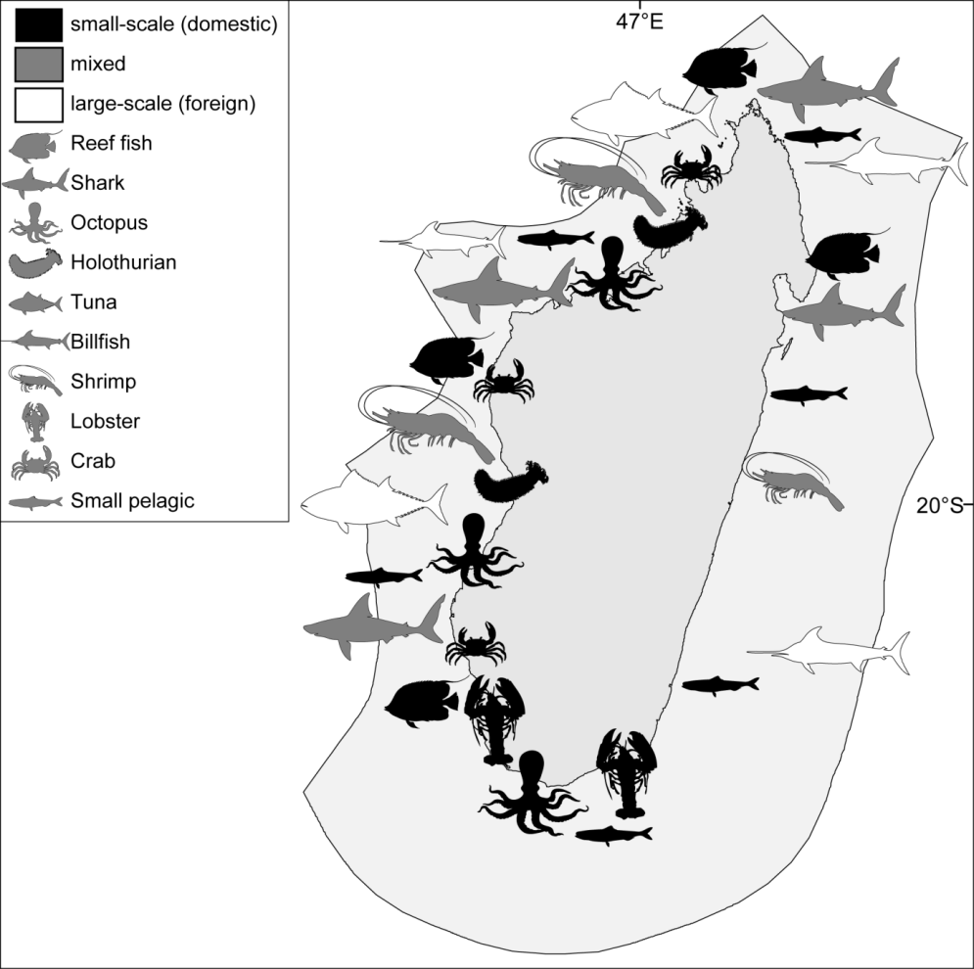
Source: Le Manach et al, 2011 & 2012

Classification of Fisheries Activities
Fisheries activities in Madagascar can be classified in terms of scale (i.e. large or small scale), capital (i.e. domestic or foreign) and sector (i.e. commercial or subsistence) (Figure 2.2). At one end of the spectrum, finfish is predominantly caught by domestic, small-scale fishers. Low-value species of finfish are kept for local consumption while high-value species are sold on national markets or to a lesser extent, exported. Octopus and lobster fisheries are largely small-scale, domestic fisheries that are fished for commercial uses, and the majority of the catch is exported.

At the other end of the spectrum, tuna fisheries are exclusively large-scale, commercial and foreign-owned. Tuna and other billfishes are either partly processed in Madagascar (and then exported to Europe), or directly shipped to Europe and Asia. Shrimp fisheries span the entire spectrum in terms of scale, capital, and sector – although partially foreign owned, large-scale commercial fisheries account for the bulk of sector activity and the majority of production is exported. The boundaries for sea cucumber and shark fisheries are more difficult to define; although fished by Malagasy people, sea cucumber fisheries are controlled by Asian traders. The majority of sharks are caught by small-scale fishers, although they also represent by-catch by foreign-owned shrimp and tuna vessels. Sea cucumbers are entirely exported, as are shark fins, while shark meat is consumed locally.

Finfish, octopus, lobster, sea cucumber and shark fisheries are essentially open-access fisheries (aside from fishing restrictions within Marine Protected Areas). Large-scale shrimp fisheries require licenses from the Ministry of Fisheries and foreign tuna and other billfish fisheries are also subject to a licensing scheme as discussed in Section II.2 below.
Figure 2.2: Organization of the different fisheries sectors in Madagascar
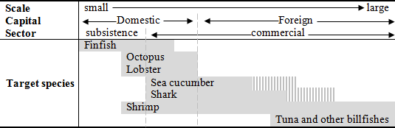
Note: Vertical stripes signify unclear boundaries.
Source: Le Manach et al, 2011 & 2012

Data on Catch Volumes
Ideally information on catch volumes across the fisheries sector would be presented in terms of the type of catch (subsistence, domestic, foreign and exported) to allow a clear understanding of the relative importance of each of these activities and to feed into the economic analysis in the following section. However, in Madagascar, official datasets on catch volumes are incomplete for certain activities, and lacking for others. This section presents both official and reconstructed data where it is available.

Subsistence catch volumes
There is no official data on subsistence catch volumes. A rule of thumb applied by the FAO provides an estimation of subsistence catch volumes in the order of 60,000 tons/year (FAO, 2011). Reconstructed fisheries statistics confirm that subsistence catch is likely a significant portion of total domestic landings (Le Manach, 2011 & 2012).

Domestic catch volumes
Official and reconstructed data on domestic catch volumes are presented in Table 2.2 and in Figure 2.3 in terms of average annual catch per decade. Official data is transmitted from the Government to the FAO, and the reconstructed data has been generated by data from a literature review and development of assumptions on those sub-sectors that are missing from official data such as finfish data from 1950 to 2008, and discards from large-scale shrimp fishing.

Table 2.2: Official and Reconstructed Statistics for Domestic Catch Volumes
Time Period | Official Catch Volumes  (average tons/year) | Reconstructed Catch Volumes  (average tons/year)
1950 – 1959 | 2,730 | 18,452
1960 – 1969 | 9,320 | 31,447
1970 – 1979 | 19,133 | 69,535
1980 – 1989 | 37,176 | 98,582
1990 – 1999 | 82,198 | 128,830
2000 – 2008 | 98,900 | 136,071
Source: Adapted from Le Manach et al, 2011 & 2012

Figure 2.3: Evolution in domestic catch volumes (1950 – 2008)
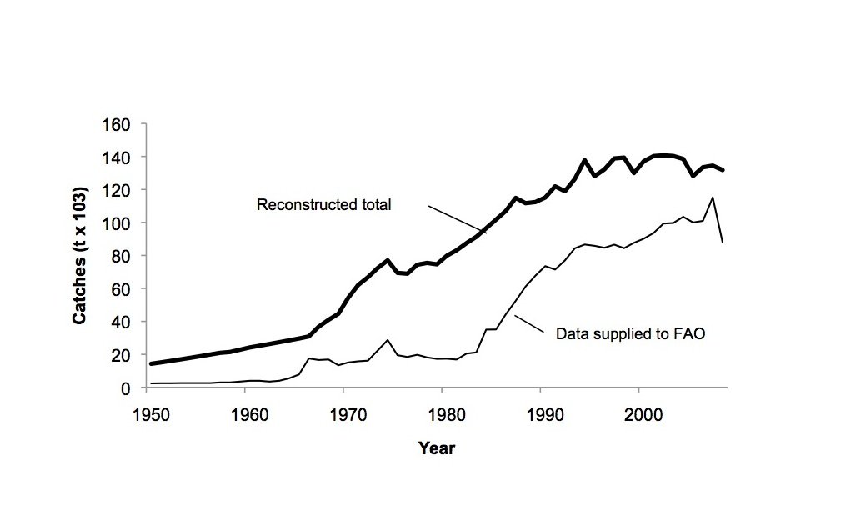
Source: Le Manach, 2012

Reconstructed data indicates that domestic catch volumes now average 136,000 tons / year. Table 2.2 and Figure 2.3 indicate that both official and reconstructed datasets demonstrate growth in domestic catch volumes between 1950 and 2008, although the reconstructed data indicate that domestic catch volumes reached a plateau in the last decade. There is a clear difference in the absolute values contained in the datasets, with official data significantly underestimating total catch volumes over the 58-year period. In latter years, since 1988, the relative difference between the two datasets has decreased although between 2000 and 2008, the average percentage difference between the reconstructed data and the FAO data is around 27%.

Foreign Catch
Reliable data on foreign catch volumes are few and far between. As noted, foreign vessels target tuna, billfish and sharks. Only vessels operating under EU licenses are required to report catch volumes. Rough estimates put maximum foreign catch volumes in the order of 80,000 tons per year; but this is a figure that should be treated with caution.

Exported Catch
Official datasets for exported catch volumes for 2010 and 2011 are presented in Table 2.3 and indicate that, on average, 21,000 tons were exported over this two-year period. Data includes both domestic catch that was exported and foreign catch (predominantly of tuna) that was landed in Madagascar, processed and then exported. A small proportion of total landings (~15%) was officially exported, although many exports were illegal and thus unreported, so this statistic is likely far too low. There is no reconstructed data on export catch volumes presented in this analysis as the missing data on exports were unavailable from the ASH and it was beyond the scope of the current study to collect import data from all importing countries.

Table 2.3: Official data on export volumes (2010 – 2011)
Commodity | Quantity (t)
Commodity | 2010 | 2011
Shrimp | 7,697 | n.a.
Farmed shrimp | n.a. | 4,046
Canned tuna | 6,713 | 8,847
Wild shrimp | n.a. | 3,070
Fish | 4,437 | 1,723
Crab | 918 | 1,015
Octopus | 1,205 | 1,106
Sea cucumber | 413 | 341
Spiny lobster | 212 | 202
Shark fin | 32 | 32
Squid | 57 | 68
Wild eel | n.a. | 11
Swim bladder | 5 | 5
Glass eel | 2 | <1
Farmed eel | n.a. | 2
Slipper lobster | 1 | <1
Bichique | <1 | n.a.
Eel | 40 | n.a.
ESTIMATED TOTAL (excluding missing data) | 21,729 | 20,467
n.a. = not available
Source: ASH

Economic Value of Catch
Economic data on the fisheries sector is patchy. The economic value of catch has been considered in terms of export value, non-fiscal revenues, total economic value and contribution to GDP.

Export Value
Export value is defined as the value of the goods at the port of export. Data on export value was sourced from ASH and is presented in Table 2.4. As noted in Table 2.4, data include both domestic catch that was exported and foreign catch (predominantly of tuna) that was landed in Madagascar, processed and then exported; no reconstructed data were generated during the current study. Table 2.4 indicates that export earnings averaged USD 136 million in 2010 and 2011. Export earnings were dominated by shrimp, then tuna and other billfish, crab, octopus, sea cucumber and spiny lobster. As many illegal or unregulated exports not included in the official statistics also took place during this period, the true value of export earnings was higher than the figures presented above.

Table 2.4: Official data on export value (2010 – 2011)
Commodity | Value (thousand USD)
Commodity | 2010 | 2011
Shrimp | 89,405 | n.a.
Farmed shrimp | n.a. | 49,920
Canned tuna | 20,786 | 29,734
Wild shrimp | n.a. | 21,665
Fish | 21,446 | 9,996
Crab | 3,927 | 3,935
Octopus | 3,693 | 3,419
Sea cucumber | 1,988 | 3,314
Spiny lobster | 3,182 | 2,779
Shark fin | 424 | 471
Squid | 265 | 343
Wild eel | n.a. | 121
Swim bladder | 100 | 36
Glass eel | 65 | 30
Farmed eel | n.a. | 17
Slipper lobster | 21 | 15
Bichique | 2 | n.a.
Eel | n.a. | n.a.
ESTIMATED TOTAL (excluding missing data) | 145,302 | 125,791
Source: ASH

Non-fiscal revenues
Non-fiscal revenues are the revenues generated for the Government that do not come from taxes. In the case of the Malagasy fisheries sector, non-fiscal revenues include mainly license fees. Data on non-fiscal revenues from fisheries was sourced from the Direction-General of the Treasury of the Ministry of Finance and Budget and presented in Figure 2.4. Data include all subsectors of fisheries – including inland fisheries and aquaculture – and no breakdown of the data was available for this report. Figure 2.4 indicates that over the last decade fiscal revenues from the fisheries sector have averaged USD 5.4 million per year. Peaks of more than USD 8 million were experienced in 2005 and 2008.

Total Economic Value
Total economic value is defined as the sum of export value, license and access fees, and domestic sales. The total economic value of the fisheries sector is difficult to calculate due to significant gaps in data. Table 2.5 presents a summary of available information in relation to total economic value of the different sub-sectors, and identifies information gaps.

Figure 2.4: Non-fiscal revenues in fisheries sector (2000 – 2010)

Source: World Bank, 2011

Table 2.5: Summary of data and data gaps for total economic value of fisheries sub-sectors (2010)
Fishery | Scale | Purpose |  | Total Economic Value  (million USD)
Shrimp | Small | Subsistence  and commercial |  | Not known
Shrimp | large | Commercial (wild + farmed) |  | 69.2
Tuna/large pelagics | Large | Commercial |  | 32.2
Shark | Small | Commercial |  | Being assessed (Blue Ventures / IOC)
Shark | Large | Commercial |  | Not known
Sea cucumber | Small | Commercial |  | Not known
Octopus | Small | Subsistence  and commercial |  | Not known
Lobster | Small | Commercial |  | Not known
Finfish | Small | Subsistence  and commercial |  | 53.6
Various invertebrates | Small | Subsistence  and commercial |  | Not known
Source: World Bank Study Team

Finfish is by far the most economically important fishery, estimated at USD 53.6 million per year. Tens of thousands of households depend on this fishery for their income and food security. The wild caught shrimp fishery’s value has dropped in recent years, from ~USD 50 million per year in 2003 to ~ USD 33 million in 2008, following an increase in fuel prices and decrease in shrimp’s market price. Tuna exports bring in USD 20.8 million annually, including foreign concession fees (USD 3.3 million per year). Despite their importance for local incomes, the total annual value of the remaining fisheries (sharks, sea cucumber, octopus, spiny lobster, and other invertebrates) is currently unknown. Ongoing analyses by the Indian Ocean Commission should be able to generate data for shark, octopus and crab fisheries in the future. Notable economic losses occur from discarded by-catch and illegal fishing by foreign vessels; the degree of which is unknown.

Contribution to GDP
Contribution to GDP is typically discussed in terms of the value-added of the sector as a proportion of the national GDP, where value-added refers to the contribution of the factors of production i.e. land, labor, and capital goods, to raising the value of a product and corresponds to the incomes received by the owners of these factors. In the case of the fisheries sector in Madagascar, there is inadequate information to calculate contribution to GDP in this manner. FAO data from 2005 indicated that fisheries contributed 3% of GDP (FAO, 2008), with the largest contribution from shrimp fisheries (Soumy, 2006), followed by export earnings and access fees. However, these data excluded key sub-sectors such as the subsistence fisheries and was based on official statistics, which as previously shown significantly underestimate catch values (Le Manach et al, 2011 & 2012). Based solely on export value data provided by ASH – again considered to be an underestimate - fisheries contributed 1.6% of GDP in 2010.

Number and Distribution of Fishers
The last census of fishers took place in 1987-88 and estimated the total number of maritime fishers at 42,000. In 2011, the Ministry of Fisheries estimated this population to be 102,000 by applying a rough rule of thumb that aligned the growth of the fisher population with overall national population growth. The result is certainly an under-estimate because it does not account for people undertaking subsistence fishing activities or fishing activities on a part-time or seasonal basis to supplement other livelihoods. Exhaustive local censuses realized by the NGO Blue Ventures provided much higher figures: 8,000 fishers in a certain area of Ranobe and 5,000 in an area of Morombe, which would already be 13% of the national total if official numbers were correct. An exhaustive fisheries census at a national level is being implemented in 2012 and 2013 with financing from the African Development Bank that will provide additional information on fisheries sector employment. As illustrated in Table 2.6 and Figure 2.5, fishers are concentrated on the west coast of Madagascar.
Table 2.6: Official statistics on fishers by district (1988 and 2011)
Province | 1988 Census | 2011 Estimates
Antsiranana | 7,437 | 14,036
Fianarantsoa | 7,760 | 14,645
Mahajanga | 12,821 | 24,196
Toamasina | 9,434 | 17,806
Toliara | 22,347 | 31,126
TOTAL | 59,799 | 101,809

Figure 2.5: Geographic distribution of fishers based on official estimates (2011)
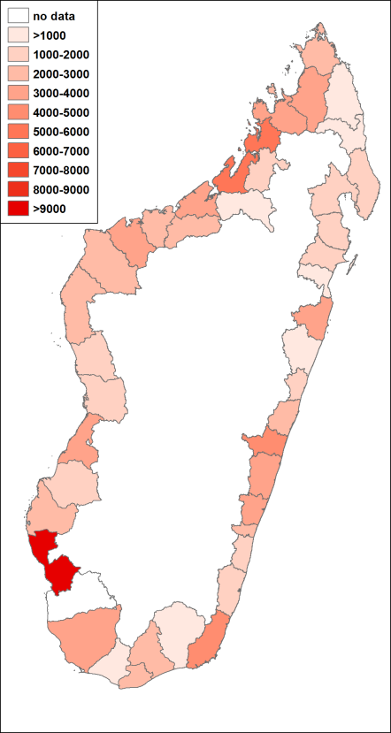
Source: Ministry of Fisheries, 2011

Fisheries Sub-Sector Profiles
Given the number of sub-sectors included in the national fisheries sector, profiles of each sub-sector have been prepared and are presented below.

Caught Shrimp
The shrimp sector is the only fishing sub-sector with relatively reliable data. The large-scale, commercial component is characterized by a mixed ownership (European, Asian and domestic), targeting shrimp (Fenneropenaeus indicus, Metapenaeus monoceros, and Penaeus semisulcatus) almost exclusively for export to Europe and Asia. The large-scale, commercial fishery officially began in 1967, after several years of exploratory surveys (Fourmanoir, 1952; Crosnier, 1965). The number of vessels steadily increased from 8 in 1967 to a peak of 79 in 2003 (Razafindrakoto, 2008), declining to 30 by 2010, although a slight increase to 37 vessels in 2011 was observed; the number of licenses has been controlled since 2000 to avoid overcapacity. Vessels operate mainly on the west coast and are 20-35 m long on average, with engines of 450 horsepower (Razafindrakoto, 2008). The usual gear is a double-twin bottom trawler, which is used no deeper than 30-40 m, the limit for economically viable exploitation. Despite its adverse environmental effects, it is unlikely, however, that trawling will be controlled, or even banned, as it has been in several other countries (e.g., Belize, Hong Kong (Anon, 2011; Real, 2011)) due to the industry’s importance to the national economy.

Official data indicates that the industrial shrimp sector was reported to be worth 70% of the marine resources contribution to GDP in 2005 (FAO, 2008; Soumy, 2006), and to be among the major employers and foreign currency earners (Razafindrainibe, 2010). In the early 2000s, the industrial shrimp sector generated around USD 55 million per year (Razafindrainibe, 2010). Due to the recent collapse of landings, the large-scale, commercial shrimp sector had sales of only USD 23.3 million in 2009 (most recent data available). This was worth 79% of the total value of seafood exports according to official data.

Traditional fishers have also intensively targeted shrimp since the 1970s and catch about 25% of total landings. Prior to that, fishers considered shrimp by-catch and used it for food. Traditional fishers are attracted by this high-value resource and now sell most of their catch to local markets. Selling their products to processing plants is no longer an option, however, as products from the traditional sector are difficult to certify for export. Most of the time, fishers operate from small wooden boats (pirogues) driven with oars and/or sail, using a variety of net types (Domalain et al, 2000; de Rodellec du Porzic & Caverivière, 2008). Their small size (3-4 m) and relative instability constrains fishers to operate in inshore areas (e.g., in estuaries or bays), or offshore but relatively close to the coast. A fleet of small ‘artisanal’ trawlers (with engines <50 horsepower) began operating in the mid-1970s, and was intended to replace the traditional fishery. However, this sector never truly expanded and halted in 2010.

After a historical peak of 13,700 tons in 2003 (traditional: 25.4%; artisanal: 5.5%; industrial 69.1%) (Figure 2.6), total catches of shrimp dropped to 5,400 tons by 2010, although preliminary data for 2011 indicate a partial rebound with around 6,700 tons from the industrial component alone. These steep declines in the shrimp fishery, once one of the most prosperous fisheries in Madagascar, are worrisome. Many hypotheses have been formulated to try to explain the collapse, but due to the lack of monitoring and reliable data, none of them seem to fully explain the situation. Official data on the non-standardized catch per unit of effort (CPUE) was oscillating but stable overall for the period 1995-2010, with on average 566 kg/fishing day (Figure 2.7). This would suggest that catches decreased in response to a fishing effort decrease. This hypothesis is corroborated by the recent lack of interest of industrial companies (McNeish, 2011), given the strong increase of fuel price (+51% between 2002 and 2009), and the drop of shrimp price (-28% between 2002 and 2009), largely due to the appearance of Latin-American and Asian shrimp on the market (Razafindrainibe, 2010). However, discussions with officials at the Ministry of Fisheries and Aquatic Resources revealed that a recent as yet unpublished study seems to show that the fishery’s non-standardized CPUE time-series provides a flawed picture of the state of the stock. This study accounted for biological parameters (e.g., migrations due to climate change) and anthropogenic parameters (e.g., change in gear type) in order to remove biases in the official data. Results from this study indicate that CPUE has been declining over time concluding that the overall effort should decrease further to recover to historical stock levels. In light of the maximum sustainable yields compiled by Hough and Marin (2009), this study makes sense. Indeed, these authors estimated that a sustainable exploitation yield should not reach over 8,200 tons per year, which has not been the case for many years (refer Figure 2.7). However, shrimp have a life cycle of around 1.5 years; the fact that the recent decrease in effort did not lead to an increase in CPUE suggests that other factors probably have a high impact, such as pollution, sea-water warming or traditional overfishing.

Figure 2.6: Evolution of shrimp landings since 1950 and comparison to MSY (2009)

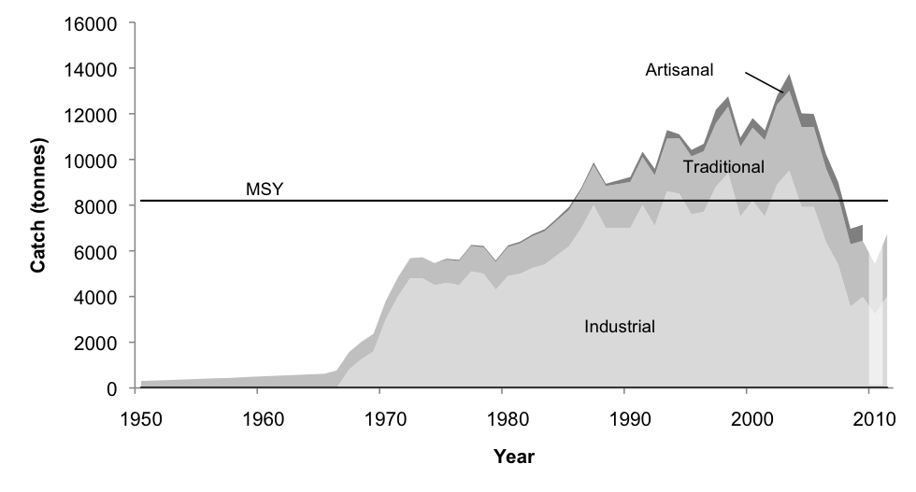
Source: Le Manach et al, 2012

Employment has also been affected by the downturn in the industry. In the early 2000s, 5,000 persons were employed by the large-scale, commercial component of this sub-sector, in addition to an unknown number of small-scale fishers. The number of employees in industrial shrimp fisheries has drastically declined - down to less than 2,000 in 2008-09 - due to a decrease in productivity.

Figure 2.7: Evolution of the fishing effort in the commercial shrimp fisheries

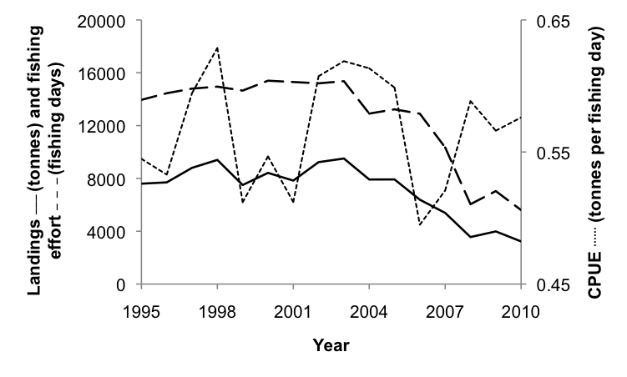
Source: GAPCM

By-catch from the shrimp fishery is a threat to food security and sustainability of many fisheries. Le Manach et al. (2011) estimate a by-catch ratio of 1:1.7 from the year 2000 onwards in Madagascar, and a discard rate of 62%. This by-catch ratio is lower than the worldwide average due to Bycatch Reduction Devices (BRD) and Turtle Extruding Devices (Alverson et al, 1994; Clucas, 1997) both of which are required by law in Madagascar. Only 38% of by-catch was considered as landed (Malagasy regulations require 0.5 kg of by-catch to be landed for each kilogram of shrimp or traded at sea, depending on the species). A recent by-catch valuation project led by FAO estimated that discards of dead fish by the shrimp fishery in Madagascar were worth USD 2.6 million each year (Razafindrainibe, 2010), which represents both an environmental and a food security threat.

Farmed Shrimp
The main farmed species is Metapeneus monodon, selected due to its higher productivity in comparison to other species (Andrianaivojaona, 1991). The production grew from 400 tons in 1994, to over 8,000 tons by 2007, dropping to below 5,000 tons in 2010 due to an increase in oil prices and a decrease in shrimp prices. To counter the negative price effects from competition (Latin-America and Asia), aquaculture companies in Madagascar increasingly focus on quality, and therefore certification, e.g., Unima shrimp are certified ‘Label Ikizuki’ (safe to eat raw, exported to Japan), and shrimp produced by OSO are certified ‘Agriculture Biologique’ (AB); an organic food label. As a result of strict regulations to gain these certifications, environmental concerns regarding Malagasy shrimp aquaculture are reportedly less than in other countries with aquaculture developments such as South American or Asian countries (Paez-Osuna, 2001). In 2009, the aquaculture sector had sales of USD 45.9 million and employed 3,338 persons, lower than the peak of USD 67.1 million in 2007, when almost 6,000 persons were employed.

Tuna, billfish, and shark
Madagascar is located south of the second most important tuna fishing ground in the world (FAO, 2010; IOTC, 2011), and therefore possesses extensive and valuable pelagic resources. Until 2008, Madagascar was unable to target large pelagic species such as tuna and sailfish, apart from small individuals caught by traditional fishers on pirogues, due to the lack of pelagic vessels, gear and knowledge. Therefore, by virtue of the United Nations Convention on the Law of the Sea (UNCLOS) Article 62, the Malagasy government had the obligation to lease this unexploited resource to other countries through fishing access agreements. In 2010, 11 agreements were in effect (Table 2). It is estimated that foreign vessels caught in the order of 80,000 tons of pelagic fish in 2008; it is not known what quantity was caught illegally. Madagascar’s treasury earned USD 3.2 million in 2010 from leases granted to 121 foreign vessels to fish for tuna and billfish. The EU is the main player (USD 2.2 million); Korea, Japan, France, and the Seychelles are also licensed.

Table 2.7: Tuna agreements effective in Madagascar (2011)
Agreement | Country | Expires | Species | Gear | Quotas | Fees
EU | EU | Dec-12 | Tunas | Longline/purse-seine | 13 300 t/year | USD 1.1 million  (+ USD 280,000)ª
Dae Young | Korea | Sep-12 | Tunas | Longline | none | USD 500^{b}  +  monthly fee based on gross tonnage^{c}
Dae Young | Korea | Undet. |  | Longline/purse-seine | none | USD 500^{b}  +  monthly fee based on gross tonnage^{c}
Dae Young | Korea | Feb-12 | Sharks | Longline | none | USD 500^{b}  +  monthly fee based on gross tonnage^{c}
Japan Tuna | Japan | Oct-11 | Tunas | Longline | none | USD 500^{b}  +  monthly fee based on gross tonnage^{c}
CFTO | France | Apr-14 | Tunas | Purse-seine | none | USD 500^{b}  +  monthly fee based on gross tonnage^{c}
Interatun | Seychelles | Mar-14 | Tunas | Seine | none | USD 500^{b}  +  monthly fee based on gross tonnage^{c}
Anabac | Seychelles | Undet. | Tunas | Seine | none | USD 500^{b}  +  monthly fee based on gross tonnage^{c}
Anabac | Seychelles | Jan-12 | Tunas | Seine | none | USD 500^{b}  +  monthly fee based on gross tonnage^{c}
Anabac | Seychelles | Jan-12 | Tunas | Seine | none | USD 500^{b}  +  monthly fee based on gross tonnage^{c}
Sapmer | France | Mar-13 | Tunas | Seine | none | USD 500^{b}  +  monthly fee based on gross tonnage^{c}
ª Side financial help to improve fisheries management (e.g., scientific monitoring)
^{b} License fee per boat
^{c} Seiners less than 1,000 tons gross registered tonnage (GRT) pay USD 3,000 per month, increasing basically linearly to USD 5,000 per month for vessels over 1,500 GRT. Longliners and pole-and-line vessels range from USD 2,000 (1,000 ton GRT) to USD 4,500 (1,500 ton GRT).
EUR 1 = USD 1.25
Source: Ministry of Fisheries

One-hundred-and-twenty-four EU vessels with an average length of 49 m (ranging from 13 to 116 m) and an average gross registered tonnage (GRT) of 717 tons (ranging from 15 to 3,400 GRT) have the right to fish in Madagascar’s EEZ. Forty of these 124 vessels based in La Réunion target marlin, swordfish and other billfish species along the east coast. These vessels are in direct competition with a newly created (2008-9) Malagasy fleet of three long-liners (Mad Ocean: 1; SPSM: 2) (Andrianaivojaona & Le Marec, 2009). European purse-seiners and longliners mainly target albacore (Thunnus alalunga) and skipjack (Katsuwonus pelamis) tuna in the northwestern part of the EEZ for canning, although they also catch non-sashimi grade yellowfin (T. albacares) and bigeye tuna (T. obesus). The EU agreement is the only foreign agreement stipulating quotas, although the language permits overshoot . The 2013 – 2014 EU quota is set to 15,000 tons per year (Le Manach, 2013; European Union, 2007), and official reports confirm that this is the amount caught, but USAID estimated catches by the European purse-seine fleet to be around 18,000 tons per year in the early 2000s (USAID, 2005). If so, the loss to Madagascar is approximately USD 588,000 per year, or 35% of the annual EU fleet’s concession fee.

Unlike EU vessels, Asian longliners (representing the majority of non-EU vessels) mainly target sashimi-grade yellowfin and big-eye tuna, which are frozen onboard and exported directly to Japan for the fresh sashimi market. A Korean fleet also specifically targets sharks. The non-EU agreements do not have any catch limits and are not based on a fee-per-ton basis, which has repercussions for the treasury income as there is no link between what is caught and what Madagascar receives. Therefore, operators can catch as much as they want, and only have to pay fees based upon the tonnage of their vessels. Madagascar’s income connected to these non-EU agreements only relates to access fees. A USD 500 access fee is paid per boat, in addition to a fee based on each vessel’s engine power and gear.

Virtually no data regarding cost of tuna fishing are publicly available, however, except fishing fees, making it difficult to calculate rents generated. Based on ex-vessel prices (USD 1440 – 1690 / ton for skipjack; USD 1190 – 2315 / ton for yellowfin) and quotas, it can be assumed that EU operators generate around USD 22 million per year (which does not include additional EU subsidies (Le Manach, 2013)). Worldwide, it is estimated that total cost of fishing amounts to 50% of the net revenue. It can therefore be assumed, for the purpose of this report, that EU operators generate a rent of approximately USD 11 million per year. An economic assessment of the European tuna fishery in Madagascar, led by WWF and currently under review, may provide more information, as well as new elements regarding local value added.

Fish processing is another important economic contribution of the tuna fishery. The national tuna cannery in Antsiranana, the third largest processing hub in the Indian Ocean in terms of tons processed each year, behind Port Victoria (Seychelles) and Port Louis (Mauritius), represents a major pole of activity in Madagascar, employing about 2,000 people. Tuna processed in Antsiranana are bought directly from EU vessels or are shipped from Mahé (Seychelles) via cargo ships. These tuna are then processed (mostly canned, and some loins) and exported to Europe. In 2010, 56,400 tons of tuna were either landed in or shipped to Antsiranana and processed by the cannery. However, data suggests that only 6,700 tons of canned tuna were exported, for a value of slightly less than USD 21 million, suggesting a data problem.

Finfish
The bulk of domestic catch is made up by finfish (65% of the estimated average 135,000 tons caught domestically each year over the past decade). The total economic contribution of finfish was estimated to be USD 53.6 million in 2010 based on market prices (Le Manach et al, 2011& 2012), 2.5 times the value of tuna exports and equivalent to the value of the shrimp fishery prior to its collapse. Indeed, the finfish sector represents a major portion of marine resources’ contribution to GDP and is crucial for local livelihoods and food security (Rabearisoa, 2011; Rabearisoa, 2012). Nonetheless, the sector is poorly understood and most of the economic contribution is not captured in official statistics, in part because most transactions occur in informal markets, and because a large portion of finfish catch is subsistence.

It is likely that all fishers in Madagascar participate in fishing for finfish, however, very little is known about small-scale fisheries and small-scale fishers as only a handful of studies estimate catches at regional or national scales (for example Laroche & Ramananarivo, 1995; Laroche et al, 1997; Le Manach et al, 2011; Rabearisoa, 2012). The studies that do exist report alarming declines in biomass and biodiversity, resulting in fishers targeting smaller and less valuable/nutritious species (Brenier et al, 2011; Gough et al, in review; Laroche et al, 1997). While catches have been increasing each year, the rate of increase has been declining, and catch volumes are expected to start declining in 2020. Coupled with population growth rates hovering near 3% per year, this poses a severe food security threat. Fishers use a wide variety of gear, including beach seines, spear guns, lines and nets, and illegal methods such as laro (cyanide), to target all species, but particularly pelagic species off the west coast.

Sharks
Fishers target all varieties of shark for their fins to supply the export market while the meat is consumed locally. In 2011, 32 tons of shark fins were legally exported (representing about 3,200 tons of shark), worth USD 471,000, 50% lower than the peak of 65 tons in 1994. Legal exports, caught primarily by thousands of small-scale fishers (employing nets that can reach several kilometers in length (Cripps, 2009; Gough et al, 2009)), likely represent only a portion of the total catch. A black market supports rampant illegal exports, and unreported shark by-catch and illegal targeting from the foreign pelagic vessels was estimated to be over 4,300 tons per year (Le Manach et al, 2011 & 2012). Likely because of overfishing, sharks have become increasingly rare. A socio-economic assessment of the current small-scale shark fishery is being undertaken by the Indian Ocean Commission and Blue Ventures.

Sea cucumbers
Sea cucumbers are highly valued and are currently worth in the order of USD 19 each, which leads to over-exploitation and dangerous fishing practices. Historically, families walked out on reef flats to glean sea cucumbers for export, but these animals are increasingly scarce due to overexploitation (Conand et al, 1997 & 1998; Rasolofonirina, 1004; Robinson & Pascal, 2009). Fishers are migrating to new areas in search of new stocks, and have resorted to more and more illegal and dangerous methods, including repeated deep dives using compressed air without decompression stops (Blue Ventures, 2012). In 2011, over 340 tons of sea cucumbers were exported for a value of over USD 3.3 million. This represented a reduction in volume but an increase in value from 2010 when 412 tons worth nearly USD 2 million were exported. Official data are likely far below actual exploitation, as most sea cucumbers are exported illegally. Even though sea cucumbers have a limited contribution to the national economy, along the west coast, sea cucumbers represent an important income source for coastal people. Recent efforts focused in the southwest of the country have centered on sea cucumber aquaculture. The business model has villagers buying juveniles from a private company, then returning once the animals are of saleable size. Pilot efforts have had to deal with high levels of poaching, and an industrial scale project was recently launched.

Octopus
The octopus fishery is characterized by women walking out onto reef flats at low tides, armed with a stake that they stab into the dens, extracting any octopus inside (mainly Octopus cyanea). Many women take part in this activity, unlike most other fisheries that involve going to sea and are dominated by men. Octopus sales are a very important income source for households along the west coast, and octopus is the largest generator of outside revenue for many villages. Nearly all octopus caught is sold to regional private sector collection companies, who collect octopus in the villages, transport them to processing plants, and export the products to Europe. Before the mid-1990s, octopuses were less intensely targeted, as there was no international market (L’Haridon, 2006; UNDESA, 2008). In 2011, 1,105 tons of octopus were exported for a value of USD 3.4 million.

The octopus fishery represents a success story in local management. In the southwest, a partnership of NGOs, the private sector, and communities has formed a Locally Managed Marine Area (LMMA), which relies upon short fisheries closures and education to restore stocks while improving incomes (Harris, 2007). Results are encouraging. The temporary closures have increased incomes from octopus harvest by leaving small portions of village fishing areas fallow for short periods (2-3 months), then harvesting the replenished stock of quick-growing octopus during an opening day derby. Tagging onto these successes, national authorities have implemented large-scale fishery closures during 6 weeks a year. Given these good results, the fishery is currently being evaluated for certification by the Marine Stewardship Council (MSC), which could boost local income and encourage the implementation of such LMMAs in other places.

Spiny lobster
Spiny lobsters (genus Panulirus) are exploited by hand or spear while snorkeling along the entire south coast of Madagascar between Toliara and Isandravinany, with a concentration in Fort Dauphin (70% of national production). High export-driven demand has driven heavy exploitation for several decades. In 1990, the FAO warned that lobsters could probably not support an increase of the fishing pressure (Kasprzyk, 1992) and in 2008, a study in the area of Fort Dauphin highlighted strong evidence of a stock collapse. The current situation is not known due to the lack of adequate scientific monitoring, but according to many local stakeholders, it is unlikely that stocks are recovering despite (ineffective and unenforced) regulations to allow stock recovery and protection of juveniles. Exports of 212 tons in 2010 were worth USD 3.2 million; in 2011, 202 tons were exported as of October, worth USD 2.8 million.

Other invertebrates
Many other invertebrates are targeted by women and children for subsistence and commercial purposes (and sometimes export), and the sector is likely quite important for household incomes and food security, however very little is known (Salimo, 1997).

Overview of Fisheries Sector Governance

Institutional Structure

Ministry of Fisheries and Aquatic Resources
Historically, fisheries have been under the mandate of the Ministry of Agriculture and Livestock (2004-2009), or have had a separate ministry (1998-2003 and 2010 to present). The fisheries sector is currently governed by the Ministry of Fisheries and Aquatic Resources (MPRH). MPRH’s mission is to conceive, implement, and coordinate the State’s fisheries and marine resource policy and research. MPRH sets policy, elaborates and enforces management rules, grants licenses, negotiates concession agreements, and ensures biosecurity of products (through ASH).

MPRH comprises over 40 directorates, services and agencies and has 184 employees: 87 at central headquarters in Antananarivo, and 97 divided across the 22 regions. The ministry’s administrative budget was USD 3.9 million in 2011, a reduction from a USD 5 million budget in 2007. MPRH’s investments fell from USD 13.2 million in 2005 to just USD 2.7 million in 2011 due to a massive decline in international donor funds following the onset of the 2009 political crisis.

Figure 3.1: Organizational structure of MPRH

MPRH
CCPS
CABINET
CCGP
UGPM
ASH
CSP
SG
SC
SLC
DAF
SAI
SF
SPSE
SLP
SRHF
DGPRH
SI
Conseil consultatif pour la Gestion des Pêcheries
DPRH
DGRH
DIRAQUA
SPM
SPC
SGPT
SSE
SVC
SStat
SAED
SAM
22 DRPRH
SAF
SRP
SRA
SRGRH
CirPRH

MPRH : Ministry of Fisheries and Aquatic Resources
CCPS : Coordination Unit for Sectoral Policy
CCGP : Coordination Unit for Project Management
UGPM : Procurement Unit
CSP : Fisheries Surveillance Center
ASH : Aquatic Sanitary Authority
SAI : Internal Audit Service
SG : Secretary-General
SC : Communication Service
SLC : Legal Service
SMS : Medical Service
DAF : Financial and Administrative Department
SF : Financial Service
SPSE : Monitoring and Evaluation Service
SLP : Heritage and Logistics Service
SRHF : Training and Human Resources Service
SI: IT Service
DGPRH : Direction General of Fisheries and Aquatic Resources
DPRH : Direction of Fisheries and Aquatic Resources
SPM : Maritime Fishing Service
SPC : Inland Fishing Service
SGPT : Tuna Fisheries Management Service
DGRH : Direction of Aquatic Resources Management
SSE : Environmental Monitoring Service
SVC : Valorization and Commercial Service
SStat : Statistics Service
DIRAQUA : Direction of Aquaculture
SAED : Service for Freshwater Aquaculture
SAM : Service for Marine Aquaculture
DRPRH : Regional Directions of Fisheries and Aquatic Resources
SRP : Regional Service for Fisheries
SRA : Regional Service for Aquaculture
SRGRH : Regional Service for Aquatic Resources
CirPRH :District Level Service for Fisheries and Aquatic Resources
SecPRH : Commune Level Service for Fisheries and Aquatic Resources

Source: MPRH, 2012

The General Directorate for Fisheries and Marine Resources (DGPRH), under the MPRH, has purview over three important sub-directorates (refer Figure 3.1): the Directorate for Fisheries and Marine Resources (DPRH), the Directorate for Marine Resource Management (DGRH), the Directorate for Aquaculture (DIRAQUA), together with all 22 Regional Directorates for Fisheries and Marine Resources (DRPRH). The roles of these sub-directorates overlap, causing confusion in assuming responsibility for managing fisheries and irrational allocation of very limited administrative resources and funds.

Three other important entities within MPRH are the Fisheries Surveillance Center (CSP), the Marine Sanitary Authority (ASH), and the Shrimp Economic Observatory (OEFC). CSP’s jurisdiction covers all Malagasy waters; the agency is responsible for applying the fisheries and aquaculture laws including monitoring and control of regulations and illegal fishing. Despite positive progress, the monitoring, control and surveillance system in Madagascar is seriously under-resourced. According the CSP, only 16.3 % of all foreign vessels (representing 7 vessels) were inspected in 2010, while 52.4% of Malagasy vessels (mainly shrimp vessels) were controlled (CSP, 2011). In 2011, the situation did not improve with 10 EU vessels (long-liners and seiners) reportedly inspected, each of them for a duration of 30 days, although data obtained from ASH officials on the monitoring effort is unclear. This latter campaign was funded by the Indian Ocean Commission, as the Government of Madagascar cannot afford to pay for such activities. Madagascar started to use a satellite monitoring system in 1998 to control its EEZ, which helped improve the monitoring of fisheries activities offshore as the geographical position of each foreign and domestic vessel equipped with a transponder in Madagascar’s waters is known.

ASH is relatively successful in fulfilling its role to ensure the sanitary security of fisheries and aquaculture products, and to control production conditions. ASH answers to both MPRH and the Ministry of Finance and Budget. Another well-functioning agency, OEFC, sits within MPRH, and helps monitor and collect official statistics on the production and economic outputs of the shrimp fishery.

The Statistical Service (SStat) and the Monitoring and Evaluation Service (SSE) of the DGPRH are also important parts of the Ministry in terms of future WAVES activities as they are responsible for the collection and management of data related to fisheries activities in Madagascar.

The Malagasy Fisheries and Aquaculture Agency (AMPA) is a public-private entity, associated with both the MFRH and Ministry of Finance and Budget that receives funding from license royalties (80% of royalties go to AMPA). It aids MPRH in financing, monitoring, and evaluating external fisheries and aquaculture projects, ensuring their sustainability and preservation of resources. It is one of the handful of institutions that fulfills its mandates. AMPA also supports CSP and ASH.

DGPRH is linked to a consultative group for fisheries management (CCGP), which is meant to bring together the technical fisheries administrators with representatives from governmental ministries of finance, environment and transport, as well as non-governmental professional groups, organizations involved in fisheries management and research, and funding agencies. The CCGP has yet to be used in any concrete way to improve sector management, although it could serve an important role in facilitating broad participation in management. A separate coordinating entity associated with the MPRH, the Inter-ministerial Fisheries and Aquaculture Commission (CIP), is composed exclusively of representatives of Ministries directly or indirectly implicated in fisheries or aquaculture (e.g., fisheries, research, environment, finance, Navy), although this commission has yet to become operational. At the regional level, consultative councils (CCPPA) were instituted in 1993, to bring together representatives of operators, ministries, and other stakeholder organizations involved in fisheries and aquaculture with regional administrative staff; these councils have not yet become operational.

Regional Directorates
DRPRHs are responsible for raising awareness of fisheries regulations, granting and renewing (and maintaining a registry of) fisher and fishmonger licenses and permits, issuing certificates of origin, and collecting statistics on fishmongers, collectors, and exporters. In relation to the shrimp fishery, DRPRH are responsible for informing fishers about procedures to mark gear, maintaining a gear registry, verifying gear markings, and receiving, verifying, and transmitting information about lost marks. Most of the regional directorates have only one or two agents, which is in most cases insufficient to carry out their multiple mandates.

Other Governmental Institutions
A number of other Governmental institutions are implicated in the fisheries sector. The National Center for Oceanographic Research (CNRO), currently unfunded, and the Institute of Marine Science (IHSM), based in Tulear, are the key state research entities. The Ministry of Environment and Forests and the National Environmental Office (ONE) are mandated to preserve ecosystems, and therefore have become involved in fisheries management through creation of Marine Protected Areas (MPA) and regulation of development activities in the coastal zone through the national environmental assessment legislation. Finally, the National Committee for Integrated Coastal Zone Management (CNGIZC) falls under the Prime-Minister’s mandate; MPRH, along with all other ministerial departments and national entities concerned with coastal and EEZ management, are members.

Private Sector and Civil Society
The private sector and civil society participate in fisheries management through some of the aforementioned governmental institutions (e.g., CCGP, CCPPA, and AMPA). Some of these mechanisms only exist on paper, however, and have never met (e.g., the fisheries consultative committee). Strong interest groups have formed professional lobbying groups. In the industrial fishing sector, one professional group is particularly strong: the Malagasy Shrimp Aquaculture and Fishers Group (GAPCM). From the small to industrial scale, GAPCM has been a leader in advancing the shrimp fishery’s management and aquaculture development. The group has also been instrumental in ensuring Malagasy interests are protected from foreign vessels. MPRH gained valuable experience in co-managing the shrimp fishery with the industry, an experience that may be translatable to other sectors. A benefit of co-management of the shrimp fishery has been the provision of data; this is the only national fishery with reliable statistics. Lobbying groups for exporters (GEXPROMER), crayfish fishers (GOLDS), and sea cucumber exploiters (ONETH) have also been established, although their memberships and power are still limited.

At a local level, civil society can participate in fisheries management through community and fisher associations. Some communities have begun managing their local marine resources through local law, called dinas, or through secured local management contracts (GELOSE) that decentralize resource management from central to local institutions. In many cases, non-governmental organizations (NGOs) support community efforts. Foreign NGOs have largely taken over responsibility for managing MPAs from the government. The fisheries administration does not accept interference from NGOs in fisheries management, however, and there are conflicting legal texts for fisheries and environmental management (refer Sections III.3 and III.4). NGOs also perform important scientific research and provide funding for ecosystem management.

Technical and Financial Partners
International institutions have long been involved in the fisheries sector in Madagascar. The IMF and World Bank mediated an agreement between the government and GAPCM to put a transparent fisheries management plan in place; FAO and UNDP have assisted the government’s fisheries efforts since the 1970s; the 3rd phase of the environmental program funded by UNDP and GEF supported marines resource management and community management of MPAs; the Indian Ocean Commission has supported a number of programs; the Indian Ocean Tuna Commission has helped reduce illegal fishing; and the African Development Bank (AfDB) and EU have financed numerous projects. The AfDB is currently financing a national fisheries census and regional productivity surveys (expected to be completed at the end of 2012). The EU, together with the FAO, is financing the SmartFish Program which has governance and technical components.

Policy Framework
No current official document specifies nor clarifies the government’s fisheries sector policy. The fisheries sector was included in the now defunct Madagascar Action Plan (2007-2012) and three successive fisheries management plans (the final expired in 2007) set ambitious strategic priorities, but the programs to implement the priorities were never effectively implemented. Consequently, the sector objectives as stated in those plans have not yet been achieved: key fisheries are not expanding, exports and products in local markets are declining, overexploitation and environmental damage continues, and basic supporting infrastructure is missing.

The Agricultural Sector Plan (2008) also included fisheries, and included a vision of moving from a subsistence to a market economy. It aimed to ensure food security, improve producer revenues, increase rural employment, increase commercialization, and ensure that future generations have access to a rich capital base of water, soil, and biodiversity. How this will be achieved in the fisheries sector is unclear. The Government has advised that an update of the Agricultural Sector Plan will be undertaken in the near future.

MPRH prepared a strategic plan to sustainably develop the aquaculture sector in 2005. The strategy, which was supported by FAO, covers fresh and marine waters, and commercial and non-commercial enterprises. It aims to improve production systems, promote aquaculture through awareness raising, research, and commercialization, and improve management through regulation and control, monitoring, and evaluation systems.

Discussions with Ministry officials indicate that the MPRH has decided to prepare a policy and management plan for the entire sector with the financing of the AMPA but this document has not yet been adopted.

Legislative Framework for the Fisheries Sector
The legislative framework governing the sector is complex and ambiguous being made up of a large number of legal instruments that are by turns overlapping and contradictory. Ordinance 93-022 (4 May 1993) and its associated Decree 94-112 (18 Feb 1994) are the main regulations governing the fisheries and aquaculture sectors. They mandate that the MPRH prepares and maintains fisheries management plans and stock conservation plans. The law also prioritizes national boats in national waters. Specifically, for coastal crustaceans and demersal fishes, small coastal fishers have priority over Malagasy industrial boats, which have priority over foreign boats operating out of Malagasy ports. In all cases, all catch must be landed in Madagascar. An old law (Decree 5 June 1922) established that the zone within 2-nautical mile of shore is reserved for small-scale fishing; this was repealed, however, in 1971 (Decree 71-238 18 May 1971) because it restricted the richest trawling area. Trawling by boats over 25 horsepower in the 2-mile area was again prohibited in 1973 (Decree 73-171 22 March 1973). Nonetheless, shrimp trawlers currently work the zone. The need to combat illegal fishing has driven MPRH to update this ordinance, although there is no consensus on the new text. The fisheries sector must also comply with the Malagasy Environmental Charter (Law 90-033 21 Dec 1990) and its associated Decree 99-954 governing the compatibility of investment and environmental concerns, and Decree 2010-137 (23 Mar 2010) regarding integrated coastal zone management.

The industrial shrimp fishery is governed by Decree 2007-957 (31 Oct 2007), which requires public-private partnerships to manage the resource for maximal economic production, while preserving the resource, environment, and rights of historical users still active in the fishery. The specific objectives of the decree are to assure long-term biological, ecological and economic sustainability of the shrimp fisheries, maximize economic efficiency of trawling to improve global competitiveness, establish a centralized database for administrative, scientific, and economic data required for managing trawling, and provide a basis for equitable royalty distribution. Effort control and individual tradable permits are two mechanisms specifically mentioned in the decree. The number of trawling licenses was frozen in 1999. 20-year licenses were granted to existing users in 2000, per Decree 2000-415 (16 Jun 2000), so no new licenses will be issued until 2019, although the licenses can be sold. Annual royalties have been collected since 1994, but in 2007, the royalties became based on gear use (per OEFC’s recommendation). Importantly, shrimp trawlers are required to land 0.5 kg of by-catch for each 1 kg of shrimp landed. In 2000, this obligation was transformed to performance indicators; and the decree of 2007 ignored the issue of by-catch altogether.

Law 2001-020 governs industrial shrimp aquaculture, but no laws govern other forms of aquaculture, an issue that the current administration foresees rectifying. The law states that all areas favorable for shrimp aquaculture are reserved for this purpose. A total of 9,000 hectares in 37 sites have been designated. These sites fall under a broad management scheme setting out recommendations and production techniques; operators wishing to establish shrimp aquaculture facilities must undertake a study and ensure that the site meets the scheme’s criteria and environmental standards. The law expresses the political will to avoid disease by restricting crustacean imports, food, density, and setting standards for sanitary conditions and minimal distances between farms. It also limits mangrove destruction by restricting the amount of mangrove cutting to 10% of the mangroves within a farm’s area.

Decree 94-112 specifies that the MPRH sets the number of foreign vessels that may fish in Malagasy waters, as well as the license period, allowable species, and quotas. Any agreements must be compatible with management plans established by MPRH. The first authorization for foreign vessels fell under an agreement with the EU signed in 1986. Arrêté 20510/2003 defined standard agreements, along with royalty payments for foreign fishing vessels targeting tuna, crustacean, and pelagic species. Notably, this law contradicts Decree 94-112, which prohibits foreign vessels to catch demersal species. Most of the tuna agreements specify that the target species is limited to tuna and similar species, although they do not specify what “similar” is. No agreements mention sharks, except for one, which requires the vessel to report shark landings. The government has been engaged with other members of the Indian Ocean Commission since 2007 to harmonize actions and unify regulations to prevent, counteract, and eliminate illegal, unreported, and unregulated fishing.

Historically, all commercial small-scale fishing has been unregulated (aside from trawling, which has always required a license). An old law (Decree 5 Jun 1922) requires collectors and fishmongers to provide technical assistance to fishers and to supply materials and gear, as well as primary goods; more recently, they must also provide statistics about their sales. The 1922 law established some rules over economically important species, but it wasn’t until the 1990s that other regulations appeared. Since 1994, all motorized fishing has been required to have a license, renewable annually. In 1997 (Arrêté 10404/97 13 Nov 1997) required authorization to fish or collect lobsters, crabs, sea cucumbers, algae, shrimp, shellfish, octopus, squid, shark fins, fish, eels, and gobies; this regulation has never been applied in practice. Since 2009, every commercial fisher and gleaner is required to have a professional card, supplied free by MPRH. In 2009, coastal shrimp fishers were granted a short (8 year) right to fish, renewable annually based on royalty payments although no payments have been demanded by MPRH.

Subsistence fishing is generally unregulated, unknown, and unmonitored. Fishing with mosquito nets, a highly destructive activity, is illegal in only 2 of 13 coastal regions. This is the only known regulation directly governing subsistence fishing.

At the time of writing the MPRH was leading the preparation of a new legislative instrument for the fisheries sector. However, a lack of consensus amongst stakeholders has meant that this legislation has not yet been adopted.

Legislative Framework for Related Activities
Community management of fisheries is not foreseen by fisheries law. The body of law enabling decentralization of resource management (GELOSE, Law 96-025 30 Sep 1006) specifies that the agreement must be made with the administrative entity that has purview over the resource in question. For fisheries, this responsibility lays with MPRH. As small-scale and subsistence fishing remains unregulated, coastal GELOSE have been authorized by the Ministry of Environment, not MPRH, which does not recognize GELOSE. Indeed, GELOSE arrangements have caused conflicts between local and migrant fishers, as well as local and industrial sectors. Marine resources are, by law, property of all Malagasy people, not just those people who live near the resources in question, which is the justification given for centralized management and why co-management has not been formally legitimized. The current legal frameworks do not acknowledge the benefits of local management, nor accept interference by NGOs or the Ministry of Environment in fisheries management.

Separate legislation exists for marine protected area creation and management and ICZM measures. To date there remains an almost complete lack of harmonization between these instruments and the fisheries legislation. The Protected Area Code (COAP) 2003 is outdated and in recognition of this, the Government prepared a new Code in 2008 that better reflects recent principles of community management of protected areas and sustainable resource use – concepts that are particularly relevant in marine and coastal zones. However, adoption of the revised Code was suspended with the onset of the political crisis and the 2003 Code remains operational. Local NGOs have been particularly active in the establishment of locally-managed marine areas (LMMAs), yet the legal framework for such activities remains unclear (refer Annex 5).

Legislation for integrated coastal zone management (ICZM) has existed since 2010 – through the adoption of Decree N°2010-137 concerning ICZM regulation in Madagascar which was issued by the Prime Minister. At a political level, ICZM has received high-level support through the creation of a national ICZM Committee and endorsement of a national strategy. However, little translation of the policy into tangible actions on the ground has been carried out in the form of regional or local level ICZM planning despite its potential as a tool to resolve conflicting resource management and land use issues in the coastal zone

Conclusions and Recommendations

Key Conclusions from Technical Case Study
The Malagasy fisheries sector is comprised of large-scale and small-scale, commercial and non-commercial sectors that target a range of species. In the last ten years, it is estimated that domestic fishers caught an average of 135,000 tons annually, and foreign fishers an additional 80,000 tons annually. Domestic fisheries are mainly comprised of subsistence, artisanal, and small-scale commercial fishers (representing 77 percent of domestic catch), largely concentrated along the west coast. Official estimates are that there are 102,000 fishers in Madagascar, although this is certainly a gross underestimate as there has been no recent census and many rural households practice fishing as seasonal or part-time occupation or as a means of supplementing their subsistence needs.

Based on official statistics, the fisheries sector contributed US$146 million or nearly 2 percent of GDP; this is a decrease of 2006 when the fisheries sector is thought to have contributed in the order of 7 percent of GDP. According to official data, finfish is by far the most economically important fishery, estimated at $53.6 million per year. Tens of thousands of households depend on this fishery for their income and food security. The shrimp fishery’s value has dropped in recent years, from ~$50 million per year in 2003 to ~$33 million in 2008, following an increase in fuel prices and decrease in shrimp’s market price. Tuna exports bring in $20.8 million annually, including foreign concession fees (US$3.3 million per year). The total annual value of the remaining fisheries (sharks, sea cucumber, octopus, spiny lobster, and other invertebrates) is unknown. Finfish, consumed domestically, represented the bulk of annual domestic landings (65 percent), a large portion of which was caught by non-commercial fishers. Other target species were mainly destined for the export market. Most shrimp were caught by industrial vessels (foreign and domestic), nearly all large pelagic fishes including sharks were landed by foreign-owned vessels, while small-scale, artisanal, and subsistence fishers caught most sea cucumbers, octopus, and lobsters. A small proportion of total landings (~15%) was officially exported, although many exports were illegal and thus unreported, so this statistic is likely far too low.

Notable economic losses to Madagascar are experienced due to discarded by-catch and illegal fishing by foreign vessels. Foreign vessels are estimated to illegally catch in the order of 50,000 tons a year, the value of which is thus lost from the Malagasy economy. By-catch from these vessels as well as shrimp trawlers totaled 12,300 tons a year, much of which was discarded or illegally sold in Asian markets. While no stock assessments have been done, the limited amount of data available indicates that most fisheries seem to be in decline with overfishing, habitat destruction, and pollution amongst the most commonly cited direct causes, and climate change and high rates of population growth inarguably amongst the most important penultimate drivers of decline.

In interpreting the above data, it is essential to bear in mind that national statistics are weak and chronically underreport landings due not only to lack of resources to enforce quotas, but by ignoring most small-scale and subsistence catch, and discarded by-catch. The total economic value of fisheries stocks and annual flows is thus very difficult to estimate due to lack of data; not only are official statistics not regularly collected but a large portion of fish are traded or sold in informal markets, or sold and exported illegally.

Despite the importance of fisheries and coastal resources to the national economy and livelihoods and subsistence needs of poor households, the current policy and legislative framework is incoherent and incomplete and is not based on a clear understanding of the true value of the country’s resources. The national sector strategy expired in 2008 and while the current Government has issued an internal discussion paper that recognizes the need to update and coordinate fisheries policy, it is not clear how or when this will be achieved. Additionally, proposed new sector-wide legislation has failed to gain consensus amongst stakeholders. Agreements with foreign operators are not based on a clear understanding of resource value and are not subject to ongoing monitoring. The shrimp industry is an important element of the sector, both in terms of revenues and foreign exchange earnings generated and employment, but significant challenges remain in its management and conflicts between industrial and traditional shrimp fishing activities exist. Aquaculture, which is an increasingly important activity, receives only limited treatment in the policy framework. A number of stakeholders including the European Union and the FAO are initiating policy dialogue in the sector and discussions are ongoing as to the possibility of a partnership between these initiatives and WAVES to allow integration of economic considerations into such activities.

Legislation for integrated coastal zone management (ICZM) has existed since 2010 and has received strong political support through the creation of a high-level national ICZM Committee. However, little translation of the policy into tangible actions on the ground has been carried out in the form of regional or local level ICZM planning despite its potential as a tool to resolve conflicting resource management and land use issues in the coastal zone. Regional ICZM Committees have been put in place in pilot zones in Madagascar, but these committees lack the capacity to integrate ecosystem accounting into policy and action plan formulation. Simultaneously, NGOs are working with local communities to develop local protected areas and local natural resource management contracts that ideally would be integrated into an overall national vision for the sector, but no guiding policy exists for such activities. Research into climate change effects in the coastal zone has been limited to date, but initial results combined with the results of global research indicate that coral bleaching and mangrove dieback could significantly affect coastal and marine resources.

Opportunities for WAVES Phase 2 Activities
Based on a consideration of the key findings of this case study and subsequent discussions with Government officials in the Ministry of Fisheries and Aquatic Resources and the National ICZM Committee two broad areas of intervention for WAVES activities have been identified.

(i) Fisheries Satellite Account Development: The activities under the second phase of WAVES could contribute to future dialogue on sector policy development through the creation of fisheries accounts that encompass the large scale commercial and small scale commercial and subsistence fisheries. The resources needed to undertake the full range of data collection needs that would be required for account development are outside the scope of the WAVES Workplan. As such a collaborative approach is proposed whereby the WAVES partnership will seek to work with other organizations undertaking data collection (e.g. Wildlife Conservation Society, the Ministry of Fisheries, the African Development Bank) to optimize the available resources.

(ii) Piloting of Regional Ecosystem Accounting and Integration with ICZM: The second clear opportunity for WAVES is in the operationalization of ICZM planning. Focusing on a pilot region in the southwest of the country, the WAVES partnership can develop methodologies, build capacity and implement ecosystem accounting that generates data to underpin regional ICZM plan development. The ecosystem accounting methodologies would address the values of fisheries, mangroves (timber and NTFP), habitat and coastal protection of coral reefs and mangroves and tourism (drawing on work in Objective 4). The effects of climate change on resources stocks and flows, and thus on values would also be investigated. The south-west of Madagascar has been selected as the initial pilot zone because there is a regional and active ICZM committee, and the zone harbors highly important fisheries and coastal resources but suffers resource conflicts and threats linked to over-exploitation and climate change (e.g. through repeated episodes of coral bleaching). The work carried out in the southwest zone would be replicated in one other priority zone, potentially the northwest, as part of the WAVES Phase 2 activities.

References

Allnutt, T.F., et al., Comparison of marine spatial planning methods in Madagascar demonstrates value of alternative approaches. PLoS ONE, 2012. 7(2): p. e28969.
Alverson, D.L., et al., A global assessment of fisheries bycatch and discards, in FAO Fisheries Technical Paper. 1994, United Nations Food and Agriculture Organization (FAO): Rome (Italy). p. 233.
Andrianaivojaona, C. and R. Le Marec, Analyse de l’exploitation des ressources halieutiques dans le cadre des protocoles d’accord de pêche. 2009, Direction Générale de la Pêche et des Ressources Halieutiques (DGPRH), Ministère de l'Agriculture, de l'Elevage et de la Pêche: Antananarivo, Madagascar. p. 53.
Andrianaivojaona, C. Valorisation des ressources halieutiques à Madagascar – Aspects politiques. 2012, Report prepared for WAVES Global Partnership / World Bank Madagascar Country Office
Andrianaivojaona, C., et al., Cahier d'information des pêches n°5. Project PNUD/FAO MAG/85/014. 1991, Direction de la Pêche et de l'Aquaculture, Ministère de la Production Animale et des Eaux et Forêts: Antananarivo (Madagascar). p. 98.
Anon., Evaluation ex-post du protocole d'accord de pêche entre Madagascar et la Communauté Européenne, et analyse de l'impact du futur protocole sur la durabilité, incluant une évaluation ex-ante. Contrat-cadre pour la réalisation d'évaluations, d'études d'impact et de suivi concernant les accords de partenariat dans le domaine de la pêche conclus entre la Communauté et les pays tiers - Convention spécifique (25) : Madagascar. Projet Fish/2003/02, Oceanic Developpement, Poseidon Aquatic Resource Management Ltd, MegaPesca Lda. 2006, Brussels (Belgium). iv + 141 p.
Anon., Evaluation ex-post du protocole d'accord de pêche entre Madagascar et la Communauté Européenne, et analyse de l'impact du futur protocole sur la durabilité, incluant une évaluation ex-ante. Contrat-cadre pour la réalisation d'évaluations, d'études d'impact et de suivi concernant les accords de partenariat dans le domaine de la pêche conclus entre la Communauté et les pays tiers - Convention spécifique (25) : Madagascar. Projet Fish/2003/02, Oceanic Developpement, Poseidon Aquatic Resource Management Ltd, MegaPesca Lda. 2006, Brussels (Belgium). iv + 141 p.
Anon., Hong Kong bans trawling to save fish stocks, in The Independent. 2011.
Bellemans, M.S., Estimations premières de la production des pêcheries traditionnelles côtières malgaches, in Field report 1989, United Nations Food and Agriculture Organization (FAO): Rome (Italy). p. 95.
Blue Ventures, Recrudescence de la pêche illégale, in L'Express de Madagascar. 2012.
Brenier, A., J. Ferraris, and J. Mahafina, Participatory assessment of the Toliara Bay reef fishery, southwest Madagascar. Madagascar Conservation & Development, 2011. 6(2): p. 60-67.
Burke, L., et al., Reefs at risk revisited. 2011, World Resources Institute, The Nature Conservancy, WorldFish Center, International Coral Reef Action Network, UNEP World Conservation Monitoring Centre and Global Coral Reef Monitoring Network: Washington, DC. p. 114.
Centre de Surveillance des Pêches (CSP), Rapport annuel d'activités - année 2010. 2011, Ministère de la Pêche et des Ressources Halieutiques, Centre de Surveillance des Pêches: Antananarivo (Madagascar). p. 50.
Cinner, J.E. and M.M.P.B. Fuentes, Human dimensions of Madagascar’s Marine Protected Areas, in Ten years after bleaching - consequences and issues facing countries in the Indian Ocean, D. Obura, J. Tamelander, and O. Linden, Editors. 2008, CORDIO/Sida-SAREC: Mombasa (Kenya). p. 397-404.
Cinner, J.E., M.M.P.B. Fuentes, and H. Randriamahazo, Exploring social resilience in Madagascar’s Marine Protected Areas. Ecology and Society, 2009. 14(1): p. 41.
Clucas, I., A study of the options for utilization of bycatch and discards from marine capture fisheries, in FAO Fisheries Circular. 1997, United Nations Food and Agriculture Organization: Rome. p. 59.
Conand, C., et al., Sea cucumbers in Madagascar: difficulties in the fishery and sustainable management. SPC Beche-de-mer Information Bulletin, 1997. 9: p. 4-5.
Conand, C., et al., Sustainable management of the sea cucumber fishery sector in Madagascar. SPC Beche-de-mer Information Bulletin, 1998. 10: p. 7-9.
Cooke, A.J., J.R.E. Lutjeharms, and P. Vasseur, Marine and coastal ecosystems, in The natural history of Madagascar, S.M. Goodman and J.P. Benstead, Editors. 2003, University of Chicago Press: Chicago. p. 179-209.
Cripps, G., Understanding migration amongst small-scale fishers in Madagascar. 2009, Blue Ventures Conservation report for ReCoMaP: Antananarivo (Madagascar).
Crosnier, A., Les crevettes Pénaeidés du plateau continental Malgache, état de nos connaissances sur leur biologie et leur pêche en septembre 1964. Cahiers ORSTOM, série Océanographie (Suppl.), 1965. 3(3): p. 158.
de Rodellec du Porzic, A. and A. Caverivière, Principaux engins de la pêche traditionnelle et leur séléctivité sur la côte nord-ouest de Madagascar (baie d'Ambaro), in Les crevettes côtières de Madagascar : biologie, exploitation, gestion, A. Caverivière, C. Chaboud, and T. Rafalimanana, Editors. 2008, IRD Editions: Marseille. p. 121-142.
Domalain, G., F. Lhomme, and N. Rasoanandrasana, La pêche crevettière traditionnelle à Madagascar : diversité spatiale, in Les espaces de l'halieutique, D. Gascuel, et al., Editors. 2000, IRD Editions: Paris. p. 387-412.
European Union, Fisheries Partnership Agreement between the Republic of Madagascar and the European Community. Official Journal L, 2007. 331: p. 7-10.
FAO, FishStatJ - Software for fishery statistical time series. v1.0.0. 2011, United Nations Food and Agriculture Organization: Rome.
FAO, Madagascar: national fishery sector overview. 2008, United Nations Food and Agriculture Organization (FAO): Rome (Italy). p. 14.
FAO, The state of world fisheries and aquaculture. 2010, United Nations Food and Agriculture Organization: Rome. p. 197.
Fourmanoir, P., Compte rendu des nouvelles expériences de pêche du « Gabriel II » effectuées du 24 juillet au 15 novembre 1951. Bulletin de Madagascar, 1952. 52: p. 17-21.
Fourmanoir, P., Les crevettes d'intérêt économique à Madagascar. Le Naturaliste Malgache, 1952. 4(2): p. 163-168.
Giri, C. and J. Muhlhausen, Mangrove forest distributions and dynamics in Madagascar (1975–2005). Sensors, 2008. 8: p. 2104-2117.
Giri, C., et al., Status and distribution of mangrove forests of the world using earth observation satellite data. Global Ecology and Biogeography, 2011. 20(1): p. 154-159.
Gough, C., et al., Status, distribution and temporal change in traditional fisheries landings in Morondava, western Madagascar: two decades of change in review.
Gough, C., et al., Vezo fishing: an introduction to the methods used by fishers in Andavadoaka southwest Madagascar. 2009, Blue Ventures Conservation Report: Antananarivo (Madagascar).
Guidicelli, M., Les pêcheries maritimes Malgaches: leurs principaux potentiels et leurs besoins pour le développement. 1984, SWIOP/Document OISO, RAF/79/065/WP/17/84: Seychelles. p. 37.
Harris, A., “To live with the Sea” development of the Velondriake community - Managed protected area network, southwest Madagascar. Madagascar Conservation & Development, 2007. 2(1): p. 43-49.
Hoegh-Guldberg, O., et al., Coral reefs under rapid climate change and ocean acidification. Science, 2007. 318(5857): p. 1737-1742.
Hough, A. and J. Marin, Rapport de pré-évaluation pour la pêcherie au chalut de crevettes côtières de la côte ouest de Madagascar. 2009, Moody Marine: London (UK). p. 82.
Instat, Tableau de Bord Economique de Madagascar. 2011, Ministry of Economy and Industry, Antananarivo.
IOTC, Report of the Thirteenth Session of the IOTC Working Party on Tropical Tunas, Lankanfinolhu, North Malé Atoll, Republic of Maldives, 16-23 October 2011, in OTC–2011–WPTT13–R. 2011, Indian Ocean Tuna Commission: Mahé (Seychelles). p. 94.
Jury, M., The climate of Madagascar, in The natural history of Madagascar, S.M. Goodman and J.P. Benstead, Editors. 2003, University of Chicago Press: Chicago. p. 75-87.
Kasprzyk, Z.W., C. Andrianaivojaona, and G. Dasylva, Pêches et aquaculture à Madagascar - Plan directeur. 1992, United Nations Food and Agriculture Organization (FAO): Rome (Italy). p. 153.
L'Haridon, L., Evolution de la collecte de poulpe sur la côte Sud Ouest de Madagascar : elements de réflexion pour une meilleure gestion des ressources, in Blue Ventures Conservation Report. 2006, Blue Ventures Conservation: London. p. 46.
Laroche, J. and N. Ramananarivo, A preliminary survey of the artisanal fishery on coral reefs of the Tulear Region (southwest Madagascar). Coral Reefs, 1995. 14(4): p. 193-200.
Laroche, J., et al., The reef fisheries surrounding the south-west coastal cities of Madagascar. Fisheries Management and Ecology, 1997. 4(4): p. 285-299.
Le Manach, F. Valuation of fisheries resources in Madagascar. 2012, Report prepared for WAVES Global Partnership / World Bank Madagascar Country Office
Le Manach, F., et al., Reconstruction of total marine fisheries catches for Madagascar (1950-2008), in Fisheries catch reconstructions: islands, part II, S. Harper and D. Zeller, Editors. 2011, Fisheries Centre, University of British Columbia: Vancouver. p. 21-37.
Le Manach, F., et al., Unreported fishing, hungry people and political turmoil: the recipe for a food security crisis in Madagascar? Marine Policy, 2012. 36: p. 218-225.
Le Manach, F., et al., Who gets what? Developing a more equitable framework for EU fishing agreements. Marine Policy, 2013. 38: 257-266.
Maina, J., et al., Modelling susceptibility of coral reefs to environmental stress using remote sensing data and GIS models. Ecological Modelling, 2008. 212(3-4): p. 180-199.
McClanahan, T.R., et al., Identifying reefs of hope and hopeful actions: contextualizing environmental, ecological, and social parameters to respond effectively to climate change. Conservation Biology, 2009. 23(3): p. 662-671.
McClanahan, T.R., et al., Recent seawater temperature histories, status, and predictions for Madagascar's coral reefs. Marine Ecology Progress Series, 2009. 380: p. 117-128.
McNeish, H., Madagascar’s Unima to close shrimp factory in March, in Bloomberg. 2011.
Ministère de la Pêche et des Ressources Halieutiques (MPRH), Enquête cadre nationale - Méthodologie. 2011, Secretariat Général de la Direction Générale de la Pêche et des Ressources Halieutiques, Ministère de la Pêche et des Ressources Halieutiques: Antananarivo, Madagascar. p. 10 + 23.
Páez-Osuna, F., The environmental impact of shrimp aquaculture: causes, effects, and mitigating alternatives. Environmental Management, 2001. 28(1): p. 131-140.
Pauly, D., From growth to Malthusian overfishing: stages of fisheries resources misuse. SPC Traditional Marine Resource Management and Knowledge Information Bulletin, 1994. 3: p. 7-14.
Pauly, D., On malthusian overfishing. Naga, the ICLARM Quarterly, 1990. 13(1): p. 3-4.
Pollnac, R.B., B.R. Crawford, and M.L.G. Gorospe, Discovering factors that influence the success of community-based marine protected areas in the Visayas, Philippines. Ocean and Coastal Management, 2001. 44(11-12): p. 683-710.
Rabearisoa, A., A rapid marine biodiversity assessment of northeast Madagascar: the socioeconomic aspects. 2011, Conservation International: Washington, DC.
Rabearisoa, A., Etudes socioéconomiques dans la région de Mitsio et Iranja. 2012, Wildlife Conservation Society: Antananarivo (Madagascar). p. 27.
Rakotoson, L.R. and K. Tanner, Community-based governance of coastal zone and marine resources in Madagascar. Ocean and Coastal Management, 2006. 49(11): p. 855-872.
Rasolofonirina, R., E. Mara, and M. Jangoux, Advances in sea cucumber aquaculture and management, in FAO Fisheries Technical Paper, A. Lovatelli, et al., Editors. 2004, United Nations Food and Agriculture Organization (FAO): Rome (Italy). p. 133-149.
Razafindrainibe, H., Baseline study of the shrimp trawl fishery in Madagascar and strategies for bycatch management. 2010, United Nations Food and Agriculture Organization (FAO). p. 111.
Razafindrakoto, H.L., Principaux traits d'évolution de la pêcherie crevettière industrielle et artisanale, in Les crevettes côtières de Madagascar: biologie, exploitation, gestion, A. Caverivière, C. Chaboud, and T. Rafalimanana, Editors. 2008, IRD Editions: Marseille. p. 93-119.
Real, N., Universal trawling ban agreement signed, in Fish Information and Services. 2011.
Robinson, G. and B. Pascal, From hatchery to community – Madagascar’s frst village-based holothurian mariculture programme. SPC Beche-de-mer Information Bulletin, 2009. 29: p. 38-43.
Salimo, R., Etude de la pêche-collecte à pied sur les platiers du Grand Récif de Toliara. 1997, Toliara (Madagascar).
Soumy, M., Country review - Madagascar, in Review of the state of world marine capture fisheries management: Indian Ocean, C. De Young, Editor. 2006, United Nations Food and Agriculture Organization (FAO): Rome. p. 365-381.
Spalding, M.D., C. Ravilious, and E.P. Green, eds. World atlas of coral reefs. 2001, University of California Press: Berkeley. 416.
UNDESA, Village of Andavadoaka, Madagascar: marine reserves for Octopus, in Innovation for Sustainable Development: Local Case Studies from Africa. 2008, United Nations Department of Economic and Social Affairs, Division for Sustainable Development. p. 14-17.
USAID, Madagascar environmental threats and opportunities assessment. 2002, United States Agency for International Development (USAID): Washington, DC (USA). p. 118.
Wilkie, M.L. and S. Fortuna, Status and trends in mangrove area extent worldwide, in Forest Resources Assessment Working Paper. 2003, Forest Resources Division, United Nations Food and Agriculture Organization: Rome.
World Bank, Madagascar country profile. 2010.
World Bank. Revue des dépenses publiques - Madagascar: politique budgétaire et investissement public en période d'instabilité politique. 2011, World Bank Country Office, Antananarivo.
World Food Programme (WFP), Madagascar: Comprehensive Food Security and Vulnerability Analysis (CFSVA), in Strengthening Emergency Needs Assessment Capacity (SENAC). 2006, World Food Programme, Vulnerability Analysis and Mapping Branch (ODAV): Rome (Italy). p. 119.

Annex 1: Number of fishers by district, in 1988 (census) and 2011 (estimates)
 |  | Number of fishers
Province | City | 1988ª | 2011^{b}
Antsiranana Antsiranana | Ambanja | 1934 | 3650
Antsiranana | Ambilobe | 1621 | 3059
Antsiranana | Antalaha | 807 | 1523
Antsiranana | Antsiranana (rural) | 1343 | 2535
Antsiranana | Nosibe | 1271 | 2399
Antsiranana | Sambava | 461 | 870
Fianarantsoa | Vohimarina | 527 | 995
Fianarantsoa | Farafangana | 812 | 1532
Fianarantsoa | Manakara-Sud | 2016 | 3805
Fianarantsoa | Mananjary | 1670 | 3152
Fianarantsoa | Nosy varika | 2188 | 4129
Fianarantsoa | Vangaindrano | 547 | 1032
Mahajanga | Vohipeno | 1498 | 2827
Mahajanga | Analalava | 2758 | 5205
Mahajanga | Antsalova | 690 | 1302
Mahajanga | Antsihihy | 791 | 1493
Mahajanga | Besalampy | 1101 | 2078
Mahajanga | Mahajanga (rural) | 1871 | 3531
Mahajanga | Maintirano | 1252 | 2363
Mahajanga | Marovoay | 1124 | 2121
Mahajanga | Mitsinjo | 1267 | 2391
Mahajanga | Port Bergé | 469 | 885
Toamasina | Soalala | 1762 | 3325
Toamasina | Ampasimanolotra | 510 | 963
Toamasina | Fenoarivo Atsinanana | 485 | 915
Toamasina | Mahanoro | 1582 | 2986
Toamasina | Mananara | 785 | 1482
Toamasina | Maroansetra | 1039 | 1961
Toamasina | Sainte Marie | 429 | 810
Toamasina | Soanierana-Ivongo | 589 | 1112
Toamasina | Toamasina (rural) | 1634 | 3084
 | Vatomandry | 619 | 1168
Toliara | Amboasary-Sud | 46 | 64
Toliara | Ambovombe-Androy | 1667 | 2322
Toliara | Ampanihy | 2161 | 3010
Toliara | Beloha | 314 | 437
Toliara | Belon-i Tsiribihina | 936 | 1304
Toliara | Manja | 893 | 1244
Toliara | Morombe | 2019 | 2812
Toliara | Morondava | 2209 | 3077
Toliara | Taolagnaro | 3157 | 4397
Toliara | Toliara | 7323 | 10200
Toliara | Tsiombe | 1622 | 2259
ª Source: 1987-88 census
^{b} Source: Ministry of Fisheries
Note: The term “fisher” refers to fishers using boats, motorized or not. These numbers do not include shore fishers and reef gleaners.

Annex 2: Official domestic fisheries statistics and reconstructed statistics
 | Reconstructed |  |  |  |  |  |  | Official data  (FAO)
Year | Large-scale |  |  | Small-scale |  | total
Year | landings | discards |  | commercial | non-commercial
1950 | - | - |  | 7185 | 7111 | 14295 |  | 2400
1951 | - | - |  | 7629 | 7541 | 15170 |  | 2500
1952 | - | - |  | 8087 | 7983 | 16070 |  | 2500
1953 | - | - |  | 8558 | 8437 | 16995 |  | 2600
1954 | - | - |  | 9042 | 8904 | 17946 |  | 2600
1955 | - | - |  | 9540 | 9384 | 18923 |  | 2600
1956 | - | - |  | 10051 | 9875 | 19925 |  | 2600
1957 | - | - |  | 10563 | 10379 | 20942 |  | 3000
1958 | - | - |  | 10831 | 10615 | 21447 |  | 3000
1959 | - | - |  | 11525 | 11285 | 22811 |  | 3500
1960 | - | - |  | 12231 | 11974 | 24205 |  | 4000
1961 | - | - |  | 12761 | 12482 | 25243 |  | 4000
1962 | - | - |  | 13303 | 13001 | 26304 |  | 3500
1963 | - | - |  | 13856 | 13531 | 27387 |  | 4000
1964 | - | - |  | 14421 | 14071 | 28491 |  | 5501
1965 | - | - |  | 14996 | 14621 | 29617 |  | 7801
1966 | - | - |  | 15701 | 15182 | 30883 |  | 17500
1967 | 1397 | 2716 |  | 16595 | 16080 | 36787 |  | 16600
1968 | 2183 | 4244 |  | 17512 | 16999 | 40937 |  | 16900
1969 | 2794 | 5432 |  | 18451 | 17941 | 44617 |  | 13400
1970 | 5239 | 10184 |  | 19719 | 19177 | 54319 |  | 15100
1971 | 6985 | 13579 |  | 21020 | 20446 | 62029 |  | 15800
1972 | 8382 | 16295 |  | 21373 | 20751 | 66801 |  | 16200
1973 | 13332 | 16295 |  | 21727 | 21055 | 72408 |  | 22401
1974 | 18298 | 15277 |  | 22081 | 21358 | 77014 |  | 28701
1975 | 9653 | 15616 |  | 22482 | 21659 | 69410 |  | 19501
1976 | 7858 | 15277 |  | 23589 | 22210 | 68934 |  | 18451
1977 | 8906 | 17313 |  | 24879 | 23256 | 74354 |  | 19760
1978 | 8731 | 16974 |  | 25565 | 24191 | 75462 |  | 18160
1979 | 7509 | 14598 |  | 27066 | 25447 | 74619 |  | 17260
1980 | 8556 | 16635 |  | 28127 | 26486 | 79804 |  | 17373
1981 | 8731 | 16974 |  | 29759 | 27669 | 83133 |  | 16875
1982 | 9168 | 17823 |  | 31573 | 28876 | 87439 |  | 20455
1983 | 9429 | 18332 |  | 33419 | 30112 | 91293 |  | 21195
1984 | 10128 | 19690 |  | 35306 | 31378 | 96501 |  | 35038
1985 | 10826 | 21048 |  | 37180 | 32651 | 101705 |  | 35112
1986 | 12223 | 23764 |  | 38061 | 32985 | 107033 |  | 44353
1987 | 13970 | 27158 |  | 39926 | 33814 | 114869 |  | 52488
1988 | 12223 | 23764 |  | 41409 | 34279 | 111675 |  | 61141
1989 | 12223 | 23764 |  | 41556 | 34831 | 112374 |  | 67731
1990 | 16976 | 19011 |  | 43454 | 35660 | 115101 |  | 73515
1991 | 19401 | 21727 |  | 44956 | 35803 | 121887 |  | 71438
1992 | 17219 | 19282 |  | 45975 | 36436 | 118912 |  | 77021
1993 | 20856 | 23356 |  | 46085 | 36095 | 126392 |  | 84317
1994 | 25212 | 23085 |  | 50853 | 38635 | 137783 |  | 86618
1995 | 18431 | 20640 |  | 50055 | 38907 | 128033 |  | 85840
1996 | 18674 | 20912 |  | 52150 | 40421 | 132157 |  | 84644
1997 | 21341 | 23899 |  | 52994 | 40574 | 138809 |  | 86547
1998 | 22797 | 25529 |  | 50874 | 40085 | 139285 |  | 84405
1999 | 18189 | 20369 |  | 50748 | 40636 | 129942 |  | 87638
2000 | 21001 | 22270 |  | 52246 | 41603 | 137120 |  | 90167
2001 | 23390 | 18954 |  | 54759 | 43137 | 140240 |  | 93615
2002 | 24002 | 12691 |  | 55833 | 48163 | 140689 |  | 99326
2003 | 23503 | 12264 |  | 56388 | 48122 | 140276 |  | 99671
2004 | 21165 | 11265 |  | 57741 | 48322 | 138493 |  | 103416
2005 | 15296 | 5818 |  | 58507 | 48527 | 128148 |  | 99986
2006 | 16236 | 6206 |  | 60175 | 50833 | 133449 |  | 100943
2007 | 15090 | 5430 |  | 60587 | 53346 | 134454 |  | 115148
2008 | 13434 | 4364 |  | 60437 | 53536 | 131771 |  | 87834
Source: Le Manach et al, 2012

Annex 3: Average market prices for fish catch
Species |  | MGA/kg |  | Species |  | MGA/kg
Acetes eurythraeus  Anisotremus surinamensis  Arius madagascariensis  Belonidae  Carangidae  Caranx ignobolis  Carcharinidae sp  Chirocentrus dorab  Clupeidae  Conger cinereus  Conger sp  Dayastidae  Ephippidae  Gazza minuta  Gerres longirostris  Gymnosarda unicolor  Holocentridae  Holothuria atra  Istiophorus platypterus  Liza vaigiensis  Lutjanus argentimaculatus  Lutjanus sanguineus  Megalopidae  Mugil cephalus  Mullidae  Mulloidicthys sp  Naucrates ductor  Otolithes ruber  Panulirus sp  Pelates quadrilineatus  Pomadasys commersonnii  Pterotolithus lateoides  Rastrelliger kanagurta  Rhinobatidae  Sardinella albella | 2 167  919  1 446  533  3 654  1 040  10 529  1 314  772  1 236  1 000  544  533  1 278  600  600  600  500  700  1 000  700  1 400  1 500  1 376  1 623  2 500  1 600  1 293  1 650  475  1 567  621  1 230  780  428 |  | Scaridae  Scomberoides commersonianus  Scomberoides lysan (juvenile)  Scomberomorus commerson  Scombridae  Scylla serrata  Selar crumenophthalmus  Serranidae  Sillago sihama  Sphyraena flavicauda  Sphyraenia barracuda  Stolephorus commersonnii  Synodontidae  Terapon jarbua  Thryssa vitrirostris  Thysanophrys arenicola  Trachurus delagoa  Trichiurus lepturus  Ulua mentalis  Crab  Fish  Salted fish  Octopus  Ray  Sea Cucumber  Dried Octopus  Salted Shark meat  Shark fin 1st  Shark fin 2nd  Shark fin 3rd  Shark meat  Squid  Shrimp  Provende (animal feed) |  | 2 600  735  467  1 481  1 778  1 000  2 350  1 110  983  1 061  1 232  1 707  917  767  742  1 150  3 333  514  520  570  751  1 688  1707  200  8 200*  1 000  1 053  144 000  74 000  38 333  431  3 000  4 867  675
Average price per unit: 30 360 MGA
1 USD = 2223 MGA (August 2012)
Data collected in collected in Ambakivao, Avaradrova, Belo-sur-mer, Betania, Borongeny, Kivalo, Morondava, Namahora, Sabora, and Tanambao
Source: Blue Ventures

Annex 4: Locally Managed Marine Areas (LMMAs) and Marine Protected Areas (MPAs) in Madagascar
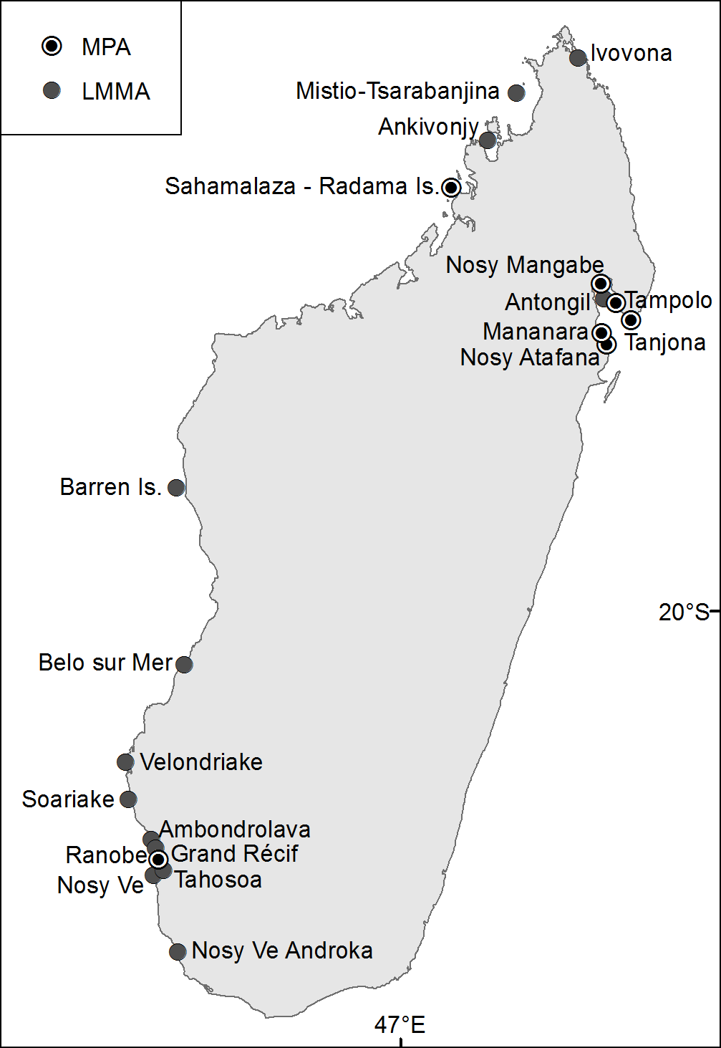
Global changes such as seawater temperature elevation and seawater acidification are expected to have massive impacts on coral reefs and associated fish (see for example Hoegh-Guldberg, 2007) that are of prime importance to Madagascar’s economy and food security as evidenced above. Madagascar was identified as being in an area of the Indian Ocean that will be substantially affected by seawater warming (McClanahan et al, 2009), although a high spatial heterogeneity exists (Maina et al, 2008; McClanahan et al, 2009). Therefore, Madagascar is likely to experience severe negative impacts from global changes, as it will probably represent another pressure on fish stocks and therefore on food security and the regional and national economies. Unfortunately, Madagascar cannot deal with this problem alone, as it must be addressed at a global level. Therefore, Madagascar should try to limit the impact of the other pressures on its resources such as overfishing, habitat destruction and pollution, in order to secure sustainable livelihoods and economy. At a national level, efforts should also be directed towards coping with resilience of socio-ecological systems in order to (i) protect productive systems, and (ii) improve the situation of already degraded systems (Cinner et al, 2009; Cinner & Fuentes, 2008).

Figure A4-1: Location of Madagascar’s MPAs and LMMAs.

MPAs are an effective tool for conservation, as well as for ensuring sustainable livelihoods for local populations, as evidenced by many studies worldwide. This tool is also seen as a way to lower the effects of global changes on marine resources, as this would relieve them from other pressures such as overfishing. Currently, Madagascar possesses 8 Marine Protected Areas managed at a national level (Table A5-1), in addition to LMMAs (Table A5-2). Madagascar’s government is willing to increase the number of MPAs, and a recent study aims to provide scientifically sound data to choose the best areas (Allnutt et al, 2012). LMMAs are increasingly considered as key conservation tools in countries with poor monitoring capabilities (such as Madagascar) (Table S1, Figure A5-1). However, transfer of power from the central government to local authorities is required for these LMMAs to be successful (Cinner & Fuentes, 2008; Pollnac et al, 2001). Several small areas are managed by villages, but they have limited legal meaning at a national level, causing non-local fishers (e.g., foreign trawlers) to not respect any of the locally enforced laws (UNDESA, 2008). However, it has been proven that such LMMAs work, from economic, social and environmental perspectives, as evidenced by the octopus reserve described above.

Table A4-1: MPAs in Madagascar
Name | Year | Status | IUCN category | Area (km²)
Cap Masoala | 1997 | Marine Park | II, VI | 21
Nosy Atafana | 1989 | Marine Park | II | 10
Nosy Mangabe | 1965 | Special Reserve | II | 6
Mananara | 1990 | Biosphere Reserve |  | 10
Sahamalaza - Radama Is. | 2001 | Biosphere Reserve |  | 322
Tampolo | 1997 | Marine Park | II, VI | 35
Tanjona | 1997 | Marine Park | II, VI | 25
Grand Récif | proposed | Marine National Park

Table A4-2: LMMAs in Madagascar
Name | Year | Management  Type | Financial/technical support | Local Organization
Nosy Ve | 2006 | Local | SAGE/ CS/MNP
Velondriake | 2006 | Local | Blue Ventures | Velondriake
Ranobe | 2007 | Local | Reef Doctor/WWF | FIMIHARA
Nosy Ve Androka | 2008 | Co-management | MNP
Maromena/Befasy* | 2008 | Local | WWF/MNP
Beheloke* | 2008 | Local | WWF/MNP
Itampolo* | 2008 | Local | WWF/MNP
Ambohibola* | 2008 | Local | WWF/MNP
Soariake | 2008 | Local | WWF/WCS/IHSM/PACP | Soariaka
Belo Sur Mer | 2009 | Local | Blue Ventures/MNP | Be Andriaky
Ivovona | 2009 | Local | Conservation International
Tahosoa | 2008 | Local | WCS/PACP/ASE/IHSM | Tahosoa
Antongil | 2009 | Local | WCS/DLIST
Ankivonjy | 2010 | Local | WCS
Barren Isles | 2011 | Local | Blue Ventures | Melaky Miaro ny Tontolo Iainana
Mistio - Tsarabanjina | 2011 | Local | WCS
Ambondrolava Mangroves | 2008 | Local | Honko/ Mamela Honko
* These sites will become part of the Nosy Ve Androka MPA being created by MNP. Therefore, this MPA will include areas to be managed by the local communities and areas to be managed by MNP.
Sources: Blue Ventures; WCS

Currently, more and more fishers around Madagascar are expressing their interest in such management plans, and more LMMAs are expected to be created in future years. A positive change is also that MNP is partnering with WWF on four LMMAs, which will become part of a national MPA network, thereby increasing possibilities of effective control and monitoring. Several other regions wish to implement such LMMAs in different parts of Madagascar, and if such a network were to be created, it could provide strong incentives for conservation by local communities all along the cost and would could help to achieve sustainability goals (Rakotoson & Tanner, 2006). The Ministry of Fisheries staff seems open to the idea of including such LMMAs in national regulations, which would therefore give them power to enforce laws within them, for example when industrial trawlers operate.

Madagascar is one of five developing country partners; the others are Philippines, Colombia, Botswana and Costa Rica.
In 2010, the primary sector “livestock and fisheries” contributed 7.2% of GDP, behind agriculture (14.4%) but ahead of forestry (4.4%) (Source: Instat, 2011)
In addition to the fisheries activities shown here, anecdotal evidence suggests that there is an unstudied seerfish fishery on the country’s west coast and small pelagic fisheries along the east coast.
Refer Annex 2 for detailed datasets.
A description of the methodology applied to generate reconstructed data is contained in Le Manach et al., 2011.
Sicyopterus lagocephalus, also known as Blue steamgoby in some locations.
Totals may not reflect sum of individual elements due to rounding
Sicyopterus lagocephalus, also known as Blue steamgoby in some locations.
Totals may not reflect sum of individual elements due to rounding
Estimates reported in Le Manach et al, 2012 put illegal catch by at 50,000 tons per year and by-catch from these vessels as well as shrimp vessels at 12,300 tons per year, much of which was discarded (finfish) or sold in Asian markets (sharks).
By ‘fishers’, the Ministry of Fisheries mostly considers persons fishing with a boat (motorized or not). Therefore, strict shore fishing activities (e.g., beach seining, reef gleaning) are missing in these estimates.
The Blue Ventures surveys included all people considering themselves to be ‘fishers’.
Refer Annex 1 for further details.
Refers to now obsolete province boundaries
See GAPCM (http://www.gapcm.org/) for detailed information; spatial information is also available in some instances.
Decree 2000-415 of June 16 2000. Replaced by Decree 200-957 of October 31 2007, which states that ‘fishing effort’ shall be based upon ‘gear units’ instead of the number of boats.
Not to be confused with the exploratory deep-sea crustacean fishery which occurred between mid-1980s and early 1990s as part of an agreement with the European Union.
A 2 nautical mile limit previously existed within which trawling was banned, but this no longer exists. Source: G. Ralison, GAPCM, pers. comm.
Source: Christian Chaboud, Institut de Recherche pour le Développement, Sète (France)
For example, the EU import regulations require very strict monitoring of each production stage, which does not allow non-industrial production to be imported in Europe.
Simply equals ‘total catch’ divided by ‘total effort’
Source: GAPCM
The industrial sector accuses the traditional sector of this collapse because it captures many juveniles by using mosquito nets. On the other hand, traditional fishers accuse industrial fishers of destroying their fishing gear (mainly jarifa shark nets and periky) and overfishing [G. Ralison, GAPCM, pers. comm; Razafindrainibe, 2010]
Only for the wild shrimp fishery; an aquaculture sector also exists, and is described separately below.
Decree 2003-1101.
Decree 2000-415; however, poor compliance explains the higher by-catch ratio used. See Le Manach et al. for details.
Since these fish are discarded and dead, they are made unavailable for local consumption and thus “exit” the ecosystem.
Source: OEFC
Composed of (i) EEZ access fees (65 EUR/t ≈ USD 81/t) and (ii) a financial support 332 000 EUR/year ≈ USD 416,000), both paid by the EU, and (iii) fishing fees paid by operators (35 EUR/t ≈ USD 44 / t)
Not all of them use this right (see ex ante/ex post assessments (Anon. 2006, 2011) available at www.transparentsea.co.
The EU agreement stipulates that “if the overall quantity of catches by Community vessels in Malagasy waters exceeds the reference tonnage, the amount of the annual financial contribution shall be increased by 65 EUR (≈ USD 81) for each additional ton caught. […] the total annual amount paid by the Community shall not be more than twice the [annual compensation] (i.e., 2,394,000 EUR (≈ USD 2,996,569)). Where the quantities caught by Community vessels exceed the quantities corresponding to twice the total annual amount, the amount due for the quantity exceeding that limit shall be paid the following year”
Except for the shark agreement, for which Madagascar does not receive any financial compensation (exploratory fishery; exempt from fees).
Source: PFOI
In the order of EUR 17.5 million
The agreement stipulates that, within the limit of 50% of the total catch, EU operators can benefit from a 5 EUR (USD 6.25) discount if they land their catch in Madagascar, and another 5 EUR (USD 6.25) discount if they sell their catch to the Antsiranana cannery. However, it appears that these discounts are not applied (Source: Ministry of Fisheries).
Source: USTA
Sources in Madagascar indicate that there is a small domestic longline fleet on the east coast that may produce accurate catch records but these records were not accessible for this report.
Decree 1975-0525 of February 5 1975 sets a minimum harvest size of 11 cm (live), or 8 cm (dried), though is unlikely that this limit was ever widely respected due to high economic incentives for sea cucumber collection coupled with weak enforcement.
Decree 2005-16376 of October 21 2005 sets closing periods (Dec 15 - Jan31 on the west coast; Jun 1 - Jul 15 on the east coast), size limits (350 g), and gear restrictions (mesh size >4 cm).
Sources: Blue Ventures; MSC
Decree 2003-119 sets a closing period from October 1st to December 31st. However, many females still bear eggs in January, and this closure time may not be optimal for stock recovery. Individuals must be at least 20 cm. It is often reported that many immature individuals are caught below 20cm, sometimes as low as 16cm.
Certain species such as mud crabs (Scylla serrata) can often be sold on national markets or to collectors for export.
Arrêté 13277/2000 (1 Dec 2000) and Decree 2007-957 (31 Oct 2007)
Decree 2005-375 (22 June 2005)
Decree 2007-957 (31 Oct 2007)
According to the Ministry of Fisheries and the CSP, the staff is composed of 18 inspectors, 7 field agents, and 21 observers, for an EEZ of 1 million km². The equipment consists of 6 zodiacs, 1 plane (100 hours of flight scheduled per year), and 3 patrol vessels (17 m, 35 m and 45 m). Most of the observers are assigned to the shrimp fishery, and only 2 inspectors were assigned to tuna fisheries in 2011.
Can be controlled via radio; does not necessarily mean inspected in person. CSP’s annual reports provide detailed information regarding the number of vessels controlled.
Source: CSP
Financed by the Agence Francaise pour le Developpement (AfD); later financed by the EU.
Decree 2005-376 of 22 June 2005
Decree 201-0639 of 30 June 2010
Ordinance 93-022 of 4 May 1993
Ordinance 93-022 of 4 May 1993
Decree 2010-137 of 23 March 2010
An industrial algae aquaculture enterprise in the northwest of Madagascar has been established by Mauritian interests. Sea cucumber farming has also been piloted in the southwest.
See for example the extensive literature on LMMAs in the Philippines.
It is only since Decree 2010-5205 that a few LMMAs benefit from a temporary (2 years) protection status.

